

**Nile University**

**School of Information Technology and Computer Science**

**Program of Computer Science**

**End-to-end AI-powered recruitment**

**platform with multimodal data input**

**(Text, Audio, Video).**

**CSCI495 Senior Project II**

**Submitted in Partial Fulfilment of the Requirements**

**For the bachelor’s degree in information technology and computer science**

**Computer Science**

**Submitted by**

**Ali Yassin - 211000161**

**Amr Ellawah- 211002202**

**Nour Elsaharty-211001756**

**Peter Saad-211002200**

**Osama Abdelaziz - 211001746**

**Youssef Nassar – 211001881**

**Supervised by**

**Dr Noha Gamal**

**Giza – Egypt**

**Spring 2025**

Table of Contents

Abstract 4

Chapter1: Introduction 6

Background of the Topic 6

Problem Statement 7

Project Objectives 9

Project Contributions 10

Chapter 2: Literature Survey 13

2.2 Surveyed Existing Solutions and Identified Gaps 16

Chapter 3: System Analysis and Design 19

3.1 High-Level System Architecture 19

3.2.1 Frontend Layer 22

3.2.2 Backend Services Layer 24

3.2.3 AI Module Layer 25

3.3 Block Diagram 28

3.4 Cheating detection 29

3.5 Use Case Diagrams 31

3.6 Sequence Diagram 33

3.7 Class Diagram 35

Chapter 4: AI and Integrative Solution 38

4.1 Dynamic Question Generation with GPT-4o mini 38

4.2 Candidate Answer Evaluation with GPT-4o 40

4.3 Speech-to-Text Transcription with Fine-tuned Whisper medium 42

4.4 Intelligent Job Recommendation with Fine-tuned BERT 44

4.5 Integration and Orchestration 46

Chapter 5: Methodology 47

5.1 Full-Stack Implementation 47

5.1.1 Frontend Development 47

5.2.2 Backend Development 49

5.2.3 Database Integration 50

5.3 AI Module Integration and Fine-Tuning 51

5.3.1 Fine-Tuning OpenAI’s Whisper for Enhanced Transcription Accuracy 52

5.3.2 Fine-Tuning BERT for Job Recommendation System 54

5.3.3 Question generation 56

5.3.4 Answers evaluation 58

5.3.4.1 Initial Approach: Jaccard Similarity 58

5.3.4.2 Transition to Semantic Similarity with BERT 60

5.3.4.3 Adoption of Label-Based Evaluation using GPT 62

Chapter 6: Results 65

6.1 AI-Related Experiments and Performance 65

6.1.1 Results and Comparative Evaluation of Candidate Answer Evaluation Methods 65

6.1.2 Fine-tuned whisper results 67

6.2 Web Experience and System Performance 68

Chapter 7: Conclusion 69

References 72

# Abstract

The modern recruitment landscape, while pivotal to organizational success, frequently contends with inherent inefficiencies, pervasive biases, and fragmented operational workflows. Traditional hiring methodologies are often characterized by their manual, time-consuming nature and susceptibility to human error. Although existing AI-driven solutions offer some degree of automation, they frequently fall short in providing the comprehensive, end-to-end capabilities essential for seamless integration of candidate evaluation, hiring automation, and robust decision support for recruiters. Addressing these critical limitations, this research introduces i-hire, an advanced AI-powered recruitment platform. i-hire innovatively unifies multimodal artificial intelligence, full-stack automation, and fairness-aware decision-making to fundamentally transform the hiring pipeline. The system is meticulously engineered to streamline recruitment processes, significantly enhance the accuracy of candidate evaluations, and cultivate a more inclusive, efficient, and transparent talent acquisition ecosystem.

i-hire achieves its objectives through the strategic integration of cutting-edge AI modules. For dynamic, job-specific question generation, it employs GPT-4o mini, meticulously controlled by a sophisticated prompt engineering approach to tailor questions precisely to specific roles and candidate responses. Candidates answer evaluation is performed using ChatGPT, which processes responses against predefined labels to deliver structured feedback. This AI-driven evaluation is then judiciously combined with manual scoring to ensure a comprehensive and nuanced assessment. For highly accurate transcription of interview responses, i-hire integrates a fine-tuned Whisper medium version, a robust speech-to-text model. Furthermore, a fine-tuned BERT model is leveraged for a powerful job recommendation system, adept at matching candidates with optimal opportunities based on their profiles and CV content. The system is architected with a React frontend and a Node.js/JavaScript backend, ensuring a scalable, responsive, and intuitive user experience.

This paper comprehensively details the architecture, implementation, and rigorous evaluation of i-hire, demonstrating its profound potential to substantially reduce hiring cycle times, improve assessment accuracy, and effectively mitigate biases. By delivering a holistic and intelligently integrated solution, i-hire aims to establish a new benchmark for transparent, scalable, and equitable talent acquisition in the contemporary era.

## Chapter1: Introduction

# Background of the Topic

The recruitment landscape has undergone profound transformations in recent decades, driven by rapid technological advancements and the evolving dynamics of the global workforce. Historically, recruitment processes were heavily reliant on manual efforts, encompassing labor-intensive tasks such as resume screening, interview scheduling, and subjective candidate evaluations. These conventional methods, while foundational to early talent acquisition, frequently suffered from inherent inefficiencies, protracted hiring cycles, and a notable susceptibility to human biases. The subjective nature of evaluations, often influenced by unconscious prejudices and inconsistent interviewer standards, routinely led to disparate hiring decisions, diminished diversity within organizations, and ultimately, missed opportunities to secure optimal talent [1].

The advent of Artificial Intelligence (AI) has heralded a paradigm shift in addressing these long-standing challenges within the recruitment domain. AI-powered solutions offer the compelling promise of data-driven insights, enabling a more objective and holistic assessment of candidates. By automating repetitive tasks and streamlining complex workflows, AI tools possess the capacity to significantly enhance decision-making processes. Early applications of AI in recruitment primarily concentrated on automating discrete stages, such as resume parsing and initial candidate screening. However, the true transformative potential resides in the development of comprehensive, end-to-end systems that seamlessly integrate diverse AI capabilities to provide an equitable and efficient hiring experience [2].

Multimodal AI systems, which are capable of processing and integrating data from various sources such as text, audio, and video have demonstrated promise in enriching candidate evaluations. Furthermore, video analysis can interpret non-verbal cues, including gestures and facial expressions. By minimizing reliance on subjective human judgments and strategically leveraging such diverse data streams, AI endeavors to facilitate faster, fairer, and ultimately more effective hiring processes [3].

# Problem Statement

Despite the considerable advancements in AI, several critical gaps persist within current recruitment practices and the existing landscape of AI-driven solutions. Many contemporary systems are predominantly recruiter-centric, focusing primarily on alleviating the workload of hiring managers while often inadvertently neglecting the candidate experience. This asymmetric focus frequently results in issues such as inadequate feedback mechanisms for applicants, limited tools for profile optimization, and a general lack of transparency in hiring decisions. The recruitment process is inherently a two-sided interaction, and systems that fail to adequately address the needs of both recruiters and candidates inevitably fall short of achieving true efficiency and equity [4].

Specifically, the prevailing challenges can be systematically categorized as follows:

Inefficiency and Time Consumption: Manual screening of resumes and traditional interview processes are notoriously time intensive. Recruiters often dedicate substantial hours to initial screenings, with a high percentage of applicants ultimately being deemed unqualified. This leads to prolonged hiring decisions and considerable administrative burdens [5].

Subjectivity and Bias: Human decision-making in recruitment is inherently prone to unconscious biases related to gender, race, and socioeconomic background. Moreover, even some AI systems, if trained on biased historical data, can inadvertently perpetuate these disparities, leading to unfair hiring outcomes and a demonstrable lack of diversity [6].

Fragmented Solutions: Many existing AI recruitment tools offer fragmented functionalities, addressing only isolated segments of the hiring process. This necessitates the use of multiple disparate platforms for sourcing, assessment, and onboarding, thereby creating disjointed workflows and impeding a holistic view of the candidate journey [7]. For example, while some tools excel in video or audio profiling, they often lack comprehensive features such as explainable AI or real-time feedback mechanisms or fail to integrate robust bias reduction strategies [8].

Lack of Candidate Support: Candidates frequently encounter significant challenges, including difficulty identifying suitable roles due to vague job descriptions, insufficient support for optimizing their professional profiles, and a severe dearth of actionable feedback on their applications or interview performance. This pervasive disconnect fosters candidate disengagement and ultimately limits career opportunities for many job seekers [9].

These multifaceted challenges underscore the urgent imperative for a comprehensive, integrated, and fair AI-powered recruitment platform that effectively addresses the limitations of both traditional and existing AI-driven approaches, thereby benefiting both employers and job seekers.

# Project Objectives

The primary objective of the i-hire system is to fundamentally revolutionize the recruitment process by establishing a sophisticated, AI-powered bridge between employers and job seekers. This endeavor involves leveraging advanced artificial intelligence to mitigate critical challenges inherent in talent acquisition and professional development. The core objectives are:

Reduce Human Biases in Candidate Evaluations: To ensure that hiring decisions are predicated purely on merit, skills, and demonstrable performance, rather than subjective judgment or unconscious biases. This will be achieved through the automation of key aspects of the recruitment process and the introduction of AI-driven evaluations that rigorously promote fairness, accuracy, and inclusiveness.

Automate Dynamic, Context-Aware Interview Question Generation: To develop and seamlessly integrate a system that utilizes Large Language Models (LLMs), specifically GPT-4o mini, to generate interview questions dynamically. These questions will intelligently adapt to each candidate’s responses and the specific job requirements, thereby creating an interactive and inherently unbiased interview simulation.

Implement Robust Candidate Answer Evaluation: To establish a comprehensive evaluation framework utilizing ChatGPT, wherein candidate answers are meticulously assessed against predefined labels. This process will yield structured feedback and facilitate the integration of manual scoring to ensure a thorough and nuanced assessment of responses.

Enable Accurate Speech-to-Text Transcription: To integrate a fine-tuned Whisper medium version AI Module for transcribing verbal responses into text. This will facilitate an unbiased assessment of content quality by enabling precise comparison of candidate answers with ideal responses and will support subsequent advanced AI processing.

Develop an Intelligent Job Recommendation System: To leverage a fine-tuned BERT model for in-depth analysis of candidate profiles and job descriptions, enabling the precise matching of candidates with highly relevant job opportunities. This system will ensure that recommendations are based on objective factors such as skills, experience, and qualifications.

Provide Comprehensive, Multi-Faceted Candidate Feedback: To offer personalized and actionable feedback to candidates regarding their interview performance, highlighting both strengths and areas for improvement. This objective aims to empower job seekers to continuously enhance their skills and confidence for future career opportunities.

Ensure Full-Stack Implementation and Integration: To construct a scalable and responsive platform featuring a React frontend and a Node.js/JavaScript backend, ensuring the seamless integration of all AI modules and a smooth, intuitive user experience for both candidates and recruiters.

By diligently achieving these objectives, i-hire aims to establish a data-driven, fair, and scalable approach to recruitment and professional development, thereby setting a new standard for equitable hiring practices.

# Project Contributions

The i-hire project is strategically positioned to make several significant contributions to the evolving field of AI-powered recruitment and broader technological applications:

Integrated End-to-End AI Recruitment Platform: Unlike many existing fragmented solutions, i-hire offers a holistic, end-to-end platform that encompasses critical stages of the recruitment process, ranging from intelligent job recommendation and dynamic question generation to comprehensive candidate evaluation and personalized feedback. This deep integration streamlines workflows and provides unified, coherent experience for both candidates and recruiters.

Novel Application of GPT-4o mini for Dynamic Question Generation: The project demonstrates an innovative and highly effective application of GPT-4o mini for generating context-aware and job-specific interview questions. This dynamic approach substantially enhances the relevance and efficacy of interviews, moving beyond the limitations of static question banks.

Structured Evaluation with Human-in-the-Loop: The proposed evaluation methodology, which judiciously combines ChatGPT-based assessment with predefined labels and expert manual scoring, offers a robust and transparent approach to candidate evaluation. This human-in-the-loop mechanism ensures heightened accuracy and permits nuanced judgment where AI alone might prove insufficient.

Leveraging State-of-the-Art AI Models for Core Functionalities: The strategic integration of a fine-tuned Whisper medium version for transcription and a fine-tuned BERT for job recommendations exemplifies the practical application of advanced AI models to resolve complex, real-world recruitment challenges, thereby enhancing efficiency and accuracy in critical operational areas.

Emphasis on Fairness and Transparency: By rigorously focusing on reducing human biases through AI-driven processes and providing clear, quantifiable evaluation metrics, i-hire makes a substantial contribution to fostering more equitable hiring practices. The system is designed to minimize discriminatory outcomes and actively promote diversity within the workforce.

Enhanced Candidate Experience: A significant and distinctive contribution of i-hire is its unwavering focus on empowering candidates through personalized feedback and realistic interview practice. This fosters continuous learning and skill development, ultimately benefiting job seekers in their ongoing career progression.

Scalable and Maintainable Architecture: The deliberate choice of React for the frontend and Node.js/JavaScript for the backend provides modern, inherently scalable, and easily maintainable architecture. This ensures the platform can efficiently handle a substantial volume of users and gracefully evolve with future technological advancements.

These collective contributions aim to collectively establish a new paradigm for AI in recruitment, offering a more efficient, fair, and supportive experience for all stakeholders involved in the talent acquisition process.

## Chapter 2: Literature Survey

Surveyed Research Papers and GapsCommercial recruitment platforms currently available on the market demonstrate varying levels of AI integration, but most focus on specific aspects of the recruitment process rather than comprehensive solutions. Platforms like HireVue utilize video interviewing technology with basic AI analysis capabilities, but their evaluation frameworks rely heavily on predetermined algorithms that may not adapt to specific organizational requirements or job categories. These systems typically provide limited customization options and may not effectively address bias concerns in diverse organizational contexts.

Applicant tracking systems (ATS) such as Workday and BambooHR incorporate AI-powered resume screening capabilities, but their matching algorithms often rely on keyword-based approaches that may miss qualified candidates whose experience is described using different terminology. These systems typically lack sophisticated natural language understanding capabilities that could provide more nuanced candidate-job matching based on semantic similarity rather than exact keyword matches.

Existing AI recruitment solutions often operate as isolated tools rather than integrated platforms, requiring organizations to manage multiple separate systems for different aspects of the recruitment process. This fragmentation creates inefficiencies in data management, candidate tracking, and overall recruitment workflow coordination. The lack of seamless integration between different recruitment tools represents a significant gap in current solution offerings.

Most commercial solutions also lack comprehensive feedback mechanisms for candidates, missing opportunities to provide value beyond the immediate recruitment process. The absence of detailed performance analytics and improvement recommendations limits the potential for candidates to benefit from their interaction with recruitment systems, reducing the overall value proposition of AI-powered recruitment platforms.

The advent of large language models (LLMs) like Generative Pre-trained Transformers (GPT) has opened new avenues for automating and enhancing various stages of the recruitment process, particularly in interview question generation and answer evaluation. Traditional methods of crafting interview questions often suffer from human biases, inconsistency, and a lack of adaptability to diverse roles and industries. GPT-based systems offer a solution by dynamically generating tailored interview questions based on job descriptions, desired skills, and even specific candidate profiles [1]. This capability ensures a broader and more relevant set of questions, potentially leading to a more comprehensive assessment of candidates. For instance, platforms are emerging that leverage GPT to create custom interview question sets, optimizing the interview process and reducing hiring time [2].

Beyond question generation, GPT models are increasingly being explored for their potential in evaluating interview answers. This application aims to bring objectivity and consistency to the often-subjective process of assessing candidate responses. By analyzing the semantic content, coherence, and completeness of answers, GPT can provide valuable insights into a candidate's suitability for a role [3]. Some researchers and developers have even built custom GPTs specifically for evaluating interviews, analyzing role-plays, data analysis tasks, and interview answers [4]. However, challenges remain in ensuring the fairness and accuracy of such evaluations, particularly in handling nuanced responses or avoiding the perpetuation of biases present in the training data. The ability to provide interactive feedback and mock interview reports is also being developed, allowing candidates to refine their responses and improve their interview performance [5].

Recommendation systems play a crucial role in modern recruitment by facilitating the matching of candidates to jobs and vice versa. While traditional recommendation systems often rely on collaborative filtering or content-based methods, the integration of Bidirectional Encoder Representations from Transformers (BERT) has significantly advanced their capabilities, especially in handling textual data inherent in resumes, job descriptions, and candidate profiles. BERT's deep understanding of language context and semantic relationships allows for more nuanced and accurate recommendations compared to keyword-based approaches [6].

By leveraging BERT embeddings, recommendation systems can move beyond simple keyword matching to identify candidates whose experience, skills, and qualifications are semantically like job requirements, even if different terminology is used. This is particularly beneficial in overcoming the limitations of traditional Applicant Tracking Systems (ATS) that might overlook qualified candidates due to variations in vocabulary. For example, systems are being developed that utilize BERT and Sentence Transformers for semantic understanding and context-aware recommendations, leading to improved recommendation quality [7]. Furthermore, BERT can be used to generate embeddings from textual data, which can then be used in various recommendation system architectures. The integration of sentiment analysis with BERT can further enhance hybrid recommendation systems by considering the emotional tone and subjective opinions expressed in textual data, offering a more holistic view of candidate-job fit.

Speech recognition technology, particularly Automatic Speech Recognition (ASR), is becoming increasingly relevant in the recruitment landscape, especially with the rise of video interviews and AI-powered conversational agents. ASR systems convert spoken language into written text, enabling the analysis of verbal responses, tone, and other vocal cues that can provide deeper insights into a candidate's communication skills and personality. While traditional ASR systems have performed well in controlled environments, challenges arise when dealing with diverse linguistic phenomena such as code-switching, where speakers alternate between two or more languages within a single conversation [8].

Research into advanced ASR systems, such as those utilizing models like Whisper, demonstrates efforts to overcome these challenges. For instance, studies have explored the application of ASR for code-switched languages, integrating it with machine translation to handle complex linguistic variations. The ability of ASR systems to effectively process and transcribe code-switched speech is crucial for recruitment platforms operating in multilingual contexts, as it ensures that valuable information from candidates is not lost due to linguistic complexities. This capability is vital for seamless interactions in various professional settings, including business negotiations and cultural exchanges, which are common in a globalized workforce. The integration of robust ASR capabilities into recruitment platforms can enhance the accuracy of candidate assessments, provide more comprehensive data for analysis, and ultimately contribute to a more inclusive and efficient hiring process.

# 2.2 Surveyed Existing Solutions and Identified Gaps

A comprehensive review of current research and commercial recruitment technologies reveals several persistent gaps that limit the effectiveness, inclusivity, and adaptability of existing solutions. Most notably, the lack of truly multimodal systems remains a critical shortcoming. While some platforms analyze individual modalities, such as voice tone, like sapia.io, or text-based responses like Fetcher.ai, very few integrate verbal content and vocal characteristics alongside linguistic understanding into a unified evaluation framework. As a result, key behavioral and communicative signals are often overlooked, leading to incomplete or superficial candidate assessments. I-Hire addresses this fundamental gap by combining audio-based transcription using Whisper with semantic understanding through GPT-4o mini and job matching via a fine-tuned BERT model. This enables the platform to perform deep linguistic and paralinguistic analysis, delivering a more comprehensive and accurate representation of candidate capabilities. Another significant gap is the absence of adaptive interview systems. Existing platforms typically rely on static question sets, offering identical or loosely templated questions regardless of the candidate’s background, role-specific requirements, or their previous responses. This rigidity results in impersonal, shallow interactions that often fail to probe relevant competencies or adapt to candidate behavior in real time. I-Hire addresses this through a real-time, context-aware question generation engine powered by GPT-4o mini. By feeding in the candidate’s previous answers, job description data, and predefined competency frameworks, the system generates dynamic follow-up questions tailored to both the role and the individual, creating a fluid, human-like interview flow.

The platform also tackles the gap between theoretical bias mitigation and real-world implementation. While many existing tools make claims about fairness or equity, few articulate a clear methodology for identifying, measuring, or reducing bias. I-Hire introduces a label-based evaluation system that employs well-defined scoring rubrics for traits such as relevance, coherence, and completeness. These rubrics are applied by GPT-4o mini under controlled prompting, ensuring evaluations are systematic and objective. By minimizing subjective interpretation and supporting auditability of model behavior, I-Hire ensures greater transparency and consistency in hiring decisions.

In addition to addressing fairness, I-Hire incorporates a cheating detection module, which is a crucial but often overlooked feature in remote and asynchronous interviews. The platform monitors audio consistency, speech anomalies, background voice interference, and irregular response patterns to flag potential integrity issues. This module is tightly integrated into the real-time transcription and evaluation pipeline, enabling automated alerts and candidate flagging when suspicious activity is detected. Such proactive integrity safeguards are essential in ensuring that AI-driven hiring remains both scalable and trustworthy.

In summary, I-Hire not only fills the technological and methodological gaps left by current recruitment tools, it sets a new benchmark by offering a fully integrated system that is multimodal, adaptive, fairness-oriented, and secure against cheating. This comprehensive, AI-enhanced approach ensures deeper insights into candidate potential, delivering more equitable, reliable, and intelligent hiring outcomes.

## Chapter 3: System Analysis and Design

This chapter provides a detailed architectural overview of the i-hire platform, illustrating its modular structure, constituent components, and their intricate interactions. A robust and well-defined system design is paramount for ensuring the platform’s scalability, maintainability, and overall operational efficiency. The design principles adopted prioritize clear separation of concerns, modularity, and extensibility to accommodate future enhancements and integrations.

# 3.1 High-Level System Architecture

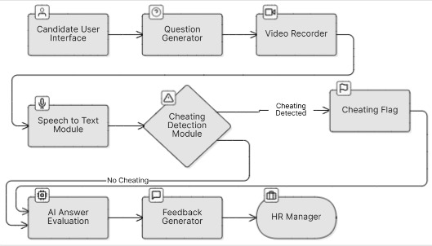

Figure 1: Flow chart

The I-Hire platform is designed around a modular architecture that emphasizes automation, fairness, and integrity in the hiring process. At a high level, the system is composed of interconnected components that handle candidate interaction, dynamic question delivery, voice transcription, cheating detection, AI-based evaluation, and result dissemination. The architecture is carefully orchestrated to ensure smooth and secure transitions between each stage of the interview while minimizing human intervention and subjective judgment.

The process begins with the Candidate User Interface, which serves as the front-end entry point to the system. Built with modern web technologies, the interface offers an intuitive environment where candidates can initiate and complete interviews. This module handles all user interactions, including displaying dynamically generated questions, collecting audio responses, and providing visual cues. The interface is optimized for responsiveness and clarity, ensuring accessibility and ease of use for candidates across devices and network conditions.

Once the candidate initiates the interview, the Question Generator is activated. Powered by GPT-4o mini, this module dynamically generates interview questions based on the job description, the candidate’s profile, and the interview context. The first few questions are standardized and curated in consultation with industry experts, particularly for behavioral interviews, ensuring that every candidate begins with a consistent baseline. After that, the system adapts the flow of questions based on candidate responses, enabling a progressive, personalized interview experience that mirrors a human conversation.

The candidate’s spoken responses are recorded and processed in real time by the Voice Capture Module, which plays a dual role in architecture. First, it supplies raw audio input to the Speech-to-Text Transcription Module, which is built on top of a fine-tuned Whisper Medium model. This model is optimized for multilingual and code-switched audio, enabling it to produce accurate transcriptions even under challenging conditions such as accents, varying speech speeds, or background noise. The transcription output is clean and structured, serving as the primary input for downstream answer evaluation.

Simultaneously, the recorded audio is passed to the Cheating Detection Module, a critical component designed to ensure the integrity of the interview process. Unlike video-based systems that analyze facial expressions or gestures, I-Hire’s cheating detection relies entirely on acoustic signals and behavioral audio patterns. This includes detecting background voices, overlapping speech, inconsistent speaker profiles, abrupt pauses, and unnatural response timing. If suspicious patterns are identified, the system triggers a Cheating Flag, which halts further automated evaluation and marks the session for manual review. This safeguard helps maintain trust in remote, unsupervised interviews by identifying attempts at dishonesty or external assistance.

If no cheating is detected, the transcribed response proceeds to the AI Answer Evaluation Module. Here, GPT-4o mini is prompted to assess the candidate’s answers using a label-based evaluation framework. Each answer is scored across multiple dimensions—such as relevance, clarity, coherence, technical accuracy (if applicable), and completeness—based on predefined rubrics. The use of structured labels and rubric-driven scoring helps eliminate subjective variability, allowing the AI to deliver consistent, explainable evaluations across candidates and interview sessions.

The outputs from the evaluation phase are fed into the Feedback Generator, which compiles detailed and personalized performance feedback for each candidate. This feedback is structured to highlight strengths, suggest areas for improvement, and reinforce learning opportunities, making the process more valuable for candidates even if they are not selected for the role.

Finally, the scores generated, flags , and feedback are presented to the HR Manager through a dedicated dashboard. This component allows human recruiters to review flagged sessions, analyze individual performance metrics, and make data-driven decisions. The integration of human oversight at this stage ensures that the system remains transparent, accountable, and adaptable to edge cases where AI decisions may require contextual interpretation.

In summary, the I-Hire system architecture reflects a thoughtful balance of automation and control. By integrating dynamic question generation, robust audio-based cheating detection, accurate transcription, and structured answer evaluation, all within a modular pipeline, the platform addresses the core limitations of traditional interview tools. It enables scalable, fair, and intelligent hiring, while maintaining integrity and human-centered values critical to the recruitment process.3.2 Component Breakdown and Interactions

# 3.2.1 Frontend Layer

The frontend of the I-Hire platform is developed using React, a popular JavaScript library known for its declarative syntax, component-based architecture, and powerful state management capabilities. React was chosen for its ability to build fast, dynamic, and scalable user interfaces while ensuring a high level of modularity and code reusability. The frontend serves as the primary access point for both candidates and recruiters, delivering a responsive, accessible, and intuitive experience across various devices and screen sizes.

For candidates, the frontend offers a streamlined and engaging interface that guides them through each stage of the interview process. From receiving dynamically generated interview questions to recording and submitting audio responses, the interface ensures smooth interaction and minimal friction. Candidates can also view AI-generated job recommendations that are tailored to their skills and background and receive detailed feedback following the interview. Special care has been taken to design the user journey with simplicity and clarity in mind, ensuring that candidates, regardless of technical proficiency, can navigate the platform easily.

On the recruiter side, the Recruiter Dashboard provides a powerful suite of tools for managing the hiring process. Recruiters can create and edit job postings, monitor interview activity in real time, and review AI-generated candidate evaluations, including performance scores, semantic similarity assessments, and behavior-based labels. They can also configure interview parameters such as question type distribution, duration, and evaluation rubrics. The dashboard consolidates all hiring-related data into a single, user-friendly interface, reducing administrative overhead and enabling data-driven hiring decisions.

The frontend is also responsible for maintaining real-time interaction with the backend. This includes establishing API calls to retrieve and post candidate data, trigger question generation modules, and receive immediate feedback from AI evaluation engines. React’s support for asynchronous operations and real-time updates ensures that the system remains highly interactive and responsive, even under heavy load. Integration with WebSockets or long polling (depending on the deployment environment) allows for near-instantaneous delivery of follow-up questions and evaluation results, making the interview experience feel conversational and adaptive.

Furthermore, the frontend is designed with accessibility and internationalization in mind, ensuring that users from diverse backgrounds and technical abilities can participate without barriers. It supports responsive layouts, keyboard navigation, and screen reader compatibility, making the platform inclusive and user-friendly.

# 3.2.2 Backend Services Layer

The Node.js/JavaScript backend acts as the central processing unit of the I-Hire platform. It orchestrates the various AI modules, manages data persistence, and exposes secure APIs for frontend communication.

The API Gateway handles all incoming requests from the frontend, routing them to the appropriate services while ensuring data integrity and security throughout the process. This layer serves as the initial point of contact between the user interface and the core system logic.

The User Management Service is responsible for managing user profiles, roles, and authentication tokens. It ensures secure access control for both candidates and recruiters, maintaining session management and user authorization. The Job Posting Service handles the creation, retrieval, update, and deletion of job postings. It provides recruiters with tools to define roles, qualifications, and other relevant metadata that shape the interview flow and recommendation models.

The Interview Management Service orchestrates the end-to-end interview process. This includes initiating question generation requests using GPT-4o mini, handling incoming candidate responses, and triggering evaluation workflows based on the AI assessment modules.

Finally, the backend handles Data Storage and Retrieval by interfacing with the database. It manages the persistent storage and retrieval of all relevant data, including candidate profiles, job postings, interview transcripts, evaluation scores, and system logs, ensuring the platform remains consistent and reliable on scale.

# 3.2.3 AI Module Layer

Each AI module within the I-Hire platform is designed to handle a distinct aspect of the intelligent hiring pipeline. These modules are modular yet tightly integrated through well-defined backend APIs, allowing them to work in concert while remaining independently scalable and maintainable. This architecture enables the platform to process, analyze, and respond to candidate inputs in real time, delivering a fluid and highly adaptive recruitment experience.

The first core module is the Question Generation Module, powered by GPT-4o mini. This component is responsible for dynamically generating personalized, context-aware interview questions. Rather than relying on static question banks, the system uses advanced prompt engineering to feed the model with structured information, including the job description, the candidate’s background, and a summary of previous responses allowing it to formulate follow-up questions that are logically progressive and role specific. This makes the interview process not only more engaging but also more effective at probing relevant competencies. For behavioral interviews, the first few questions are standardized and carefully curated in collaboration with HR professionals and industry experts to ensure consistency and fairness. After this baseline, the system dynamically adapts, enabling more natural and human-like conversations.

The Speech-to-Text Transcription Module forms the next critical step in the pipeline. Built on a fine-tuned version of the Whisper Medium model, this module handles real-time conversion of spoken responses into text. The model has been fine-tuned on a code-switched Arabic-English dataset (ArzEn) with over 6,000 audio samples, enabling it to transcribe diverse linguistic inputs with high accuracy. The training data included interviews with varied accents, noise conditions, and spontaneous speech patterns, common in remote recruitment settings, making the model robust in real-world scenarios. The transcriptions generated by this module are structured and clean, serving as the primary input for semantic evaluation and further downstream processing. Compared to off-the-shelf speech-to-text solutions, this fine-tuned model shows significantly reduced Word Error Rate (WER) and Character Error Rate (CER), especially on complex, multi-language interview responses.

Following transcription, candidate answers are routed to the Answer Evaluation Module, where GPT-4o mini is again employed to conduct structured analysis. This module uses a label-based evaluation framework developed specifically for the I-Hire platform. Responses are assessed across multiple predefined labels such as relevance, clarity, coherence, technical accuracy (for technical roles), completeness, and conciseness. Each label is associated with a detailed scoring rubric, and GPT-4o mini is prompted with both the label definitions and an ideal reference answer where applicable. This approach allows the model to generate granular feedback and assign scores in a consistent, auditable way. The structured nature of the evaluation not only improves objectivity but also provides meaningful, actionable insights for both candidates and recruiters. It has proven especially effective in evaluating behavioral answers, where traditional semantic similarity models like BERT struggled with variability in language use.

The final step in the AI pipeline is the Job Recommendation Module, which leverages a fine-tuned BERT model for matching candidates with relevant job opportunities. This model was trained on a structured dataset of job descriptions and candidate resumes (CVs), specifically the lang-uk/recruitment-dataset-job-descriptions-english, using a two-epoch training cycle and 250 evaluation steps. During training, the model was optimized for semantic similarity and suitability prediction using cosine similarity loss. Only essential columns like job titles, job description, and candidate experience, were retained after thorough preprocessing and normalization. The fine-tuned BERT model excels at capturing conceptual alignment between a candidate’s profile and job requirements, moving beyond simple keyword overlap to deliver highly relevant, personalized job recommendations. These recommendations are shown to the candidate at the end of the interview and are also accessible to recruiters via the dashboard.

Together, these AI modules form the cognitive backbone of the I-Hire system. Their integration through a well-structured backend allows for a seamless, end-to-end interview and evaluation experience. From generating questions that adapt to individual candidates, to transcribing responses with high fidelity, evaluating answers across defined dimensions, and recommending jobs with contextual precision—each module contributes to a highly intelligent, efficient, and fair hiring ecosystem.

# 3.3 Block Diagram

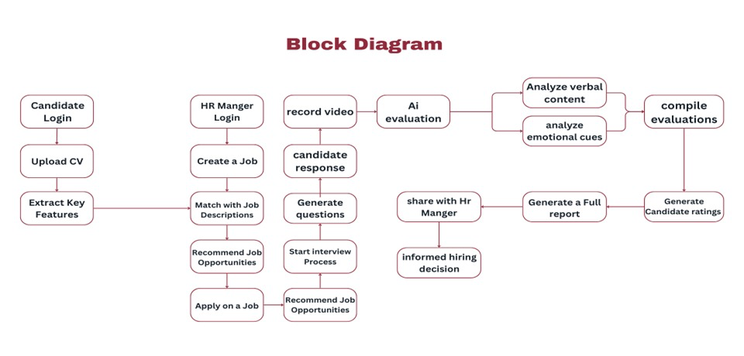

Figure 2: Block diagram

The I-Hire system block diagram illustrates the comprehensive integration of frontend components, backend services, database systems, and AI modules that collectively enable seamless recruitment process automation1. The user interface layer encompasses separate interfaces for candidates and recruiters, each optimized for specific workflow requirements and user experience considerations. Candidate interfaces provide access to job search functionality, profile management, interview scheduling, and real-time interview participation with immediate feedback capabilities.

Recruiter interfaces offer comprehensive tools for job posting management, candidate review and evaluation, interview scheduling and monitoring, and detailed analytics reporting that supports data-driven hiring decisions. Both interface types implement responsive design principles that ensure optimal functionality across desktop and mobile platforms, providing flexibility for users to access the system from various devices and locations.

The backend service layer consists of multiple microservices that handle specific functional domains including user management, job posting and matching services, interview management, AI model coordination, and reporting and analytics generation. These microservices communicate through well-defined API interfaces that ensure system modularity and enable independent scaling of different service components based on usage patterns and performance requirements.

The AI services integration block encompasses the coordination of multiple artificial intelligence technologies that provide the platform's advanced capabilities. GPT-4o Mini integration handles dynamic question generation based on job requirements and candidate responses, while BERT model implementation provides sophisticated job-candidate matching based on semantic analysis of skills, experience, and qualifications. Whisper integration enables accurate speech-to-text conversion for interview transcription, and custom evaluation algorithms process multimodal data to generate comprehensive candidate

will depict Level 1 DFDs, breaking down the main processes into sub-processes and showing the flow of data between them. These diagrams will highlight how data is captured, processed, and transformed as it moves through the i-hire platform, from candidate interaction to final evaluation and recommendation.

# 3.4 Cheating detection

The Enhanced Cheating Detection System in the I-Hire platform is architected as a modular, real-time monitoring engine that integrates seamlessly with the video interview flow. It begins by interfacing with the video stream captured during candidate interviews, which is continuously analyzed through a multi-stage pipeline. This pipeline includes a Detection Engine, Risk Scoring System, and Alert Module, all orchestrated to operate in real-time. The Detection Engine houses submodules for face tracking, device detection, and movement analysis, each responsible for extracting specific behavioral features from video frames. These features are then passed to the Risk Scoring System, which applies weighted algorithms to calculate an overall risk score based on observed anomalies. If the score crosses a predefined threshold, the Alert Module flags the interview as suspicious and routes the case to human reviewers via the backend.

The architecture supports modular extensibility, allowing future plug-ins such as audio violation monitoring or advanced object detection (e.g., earbuds, phones) without disrupting the existing workflow. It is also designed to be configurable, enabling recruiters or platform administrators to adjust detection sensitivity and violation thresholds depending on the organization's strictness level. Integration with the frontend enables real-time feedback and alerts, while the backend stores detection logs, scores, and violation metadata for later review. This high-level modular structure ensures performance, scalability, and adaptability for varied hiring environments.

# 3.5 Use Case Diagrams

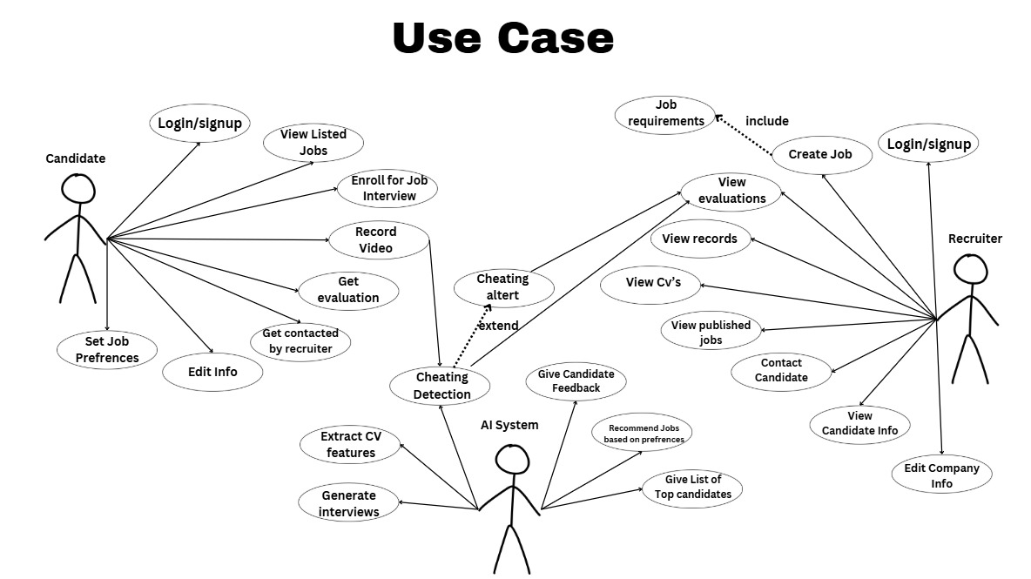

Figure 3: Use Case Diagram

The use case diagram illustrates the core functionality of the I-Hire platform by depicting the interactions between three main actors: the Candidate, the Recruiter, and the AI System. Each actor engages with the system through a set of well-defined use cases that support a streamlined, intelligent hiring workflow. These cases collectively represent the functional capabilities of the platform, from initial login to final job matching and feedback.

The Candidate begins their journey on the platform by logging in or signing up, which grants them access to various job-seeking functionalities. Once authenticated, candidates can view listed jobs and set their job preferences, helping to tailor recommendations to their unique interests and qualifications. They may edit their personal information, enroll for interviews, and record video responses to dynamically generated questions. These video recordings are submitted through the platform for evaluation. After the interview, candidates receive structured feedback and scores based on AI evaluation. Additionally, they may be contacted directly by recruiters if their profiles align with available roles.

On the other side of the hiring pipeline, the Recruiter also logs in or signs up to access their management dashboard. From there, they can create job postings by specifying job requirements, which are then used throughout the system to generate tailored interview questions and inform candidate evaluations. Recruiters can view candidate records, including CVs, published job posts, and performance evaluations. Based on this data, they can contact potential candidates, make informed hiring decisions, and edit their company profiles when necessary. The recruiter’s interface serves as a hub for managing talent acquisition and maintaining a pool of qualified applicants.

The AI System serves as the intelligent backbone of I-Hire, powering critical automated processes. It begins by extracting key features from candidate CVs, such as skills, experiences, and educational background, which are then used for matching and evaluation. The system generates interview questions tailored to both the job role and the candidate’s profile using a context-aware GPT-4o model. Once the candidate submits their video responses, the AI system transcribes their speech using a fine-tuned Whisper model and evaluates their answers using a label-based framework for clarity, relevance, technical accuracy, and completeness. It also provides job recommendations based on the candidate’s preferences and performance and compiles a list of top candidates for recruiters. An essential part of the system is the Cheating Detection Module, which monitors candidate behavior during the interview for signs of misconduct. If cheating is detected, a flag is raised and the recruiter is alerted, by passing the evaluation pipeline and preventing the feedback from being generated until further review.

# 3.6 Sequence Diagram

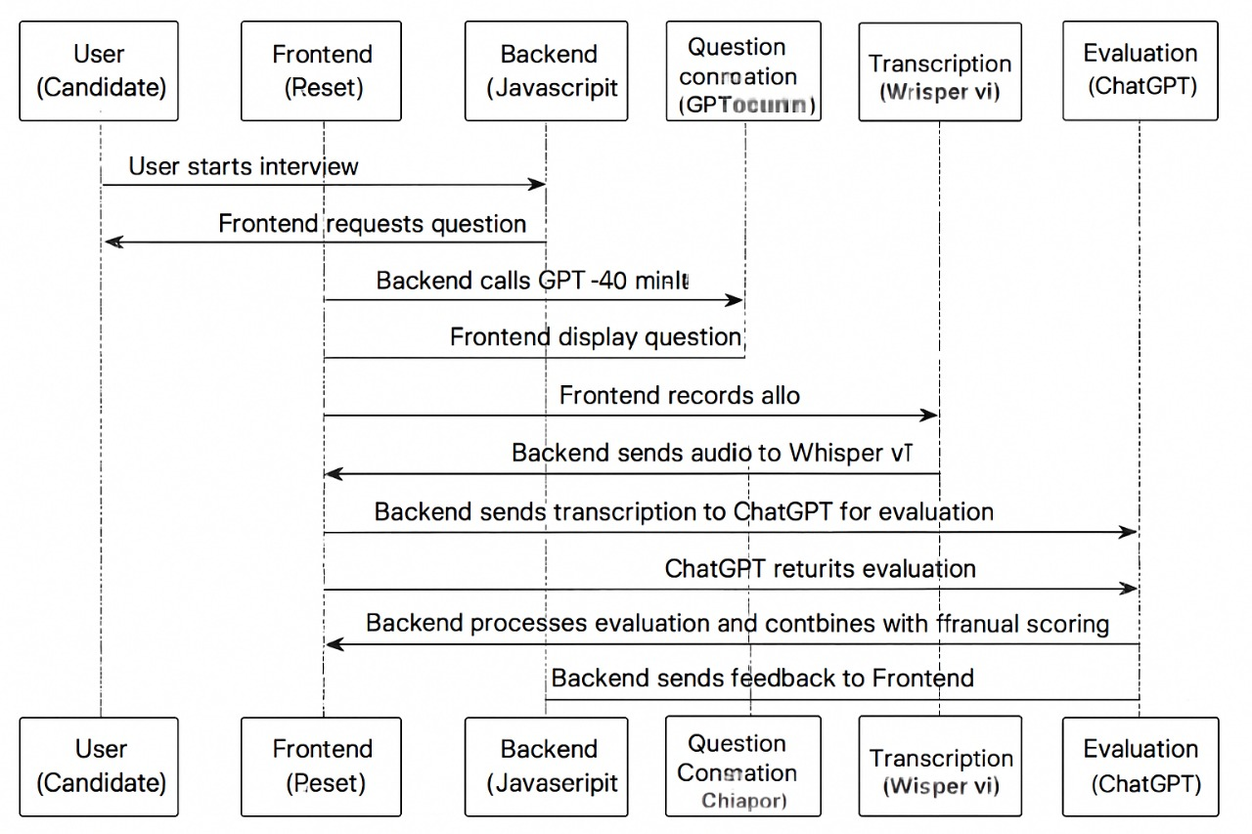

Figure 4:Sequence Diagram.

This sequence diagram illustrates the real-time workflow of the I-Hire interview process, involving six primary components: the Candidate, Frontend Interface, Backend Server , the Question Generation Module, the Transcription Module, and the Evaluation Module.

The process begins when the candidate initiates an interview session from the user interface. The frontend sends a request to the backend to fetch a question. In response, the backend calls the GPT-4o Mini question generation module, which dynamically creates a context-aware and job-specific question based on previous candidate responses and the job description. This question is then delivered back to the frontend, where it is displayed to the candidate.

Once the question is visible, the candidate responds verbally, and the frontend captures the audio recording of the answer. The recorded audio is then sent by the backend to the Whisper v1 transcription module, which has been fine-tuned for domain-specific accuracy in noisy, real-world conditions. This module converts the audio into a precise text transcription.

After successful transcription, the backend forwards the transcript to the GPT-based evaluation module, which has been fine-tuned to assess answers using label-based criteria such as clarity, completeness, relevance, and coherence. The evaluation module returns structured scores and textual feedback to the backend.

Following this, the backend performs post-processing, possibly combining AI evaluation results with any optional rule-based or manual scoring logic. Once the final evaluation is ready, the feedback is sent back to the frontend, where it is displayed to the candidate in an easy-to-understand format. This completes the interview loop, offering a seamless and intelligent end-to-end user experience powered by tightly integrated AI services and system components.

# 3.7 Class Diagram

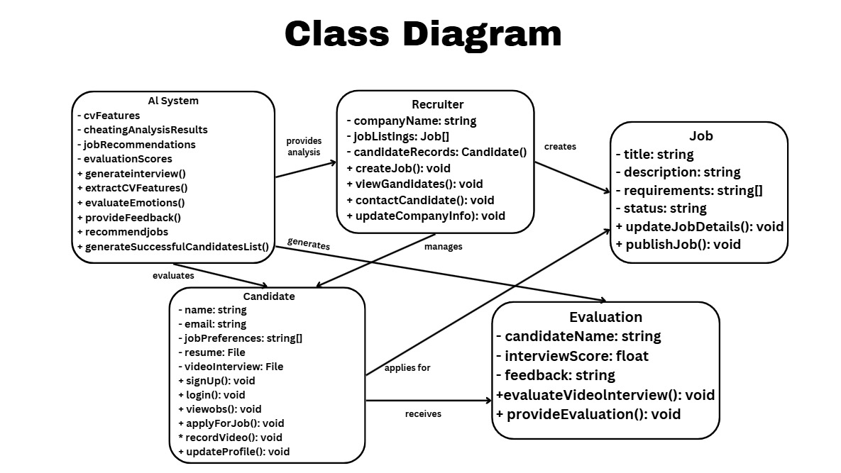

Figure 5: Class Diagram

The class diagram represents the core structure of the I-Hire intelligent recruitment platform, outlining how different entities interact within the system. It includes six primary classes: Candidate, Recruiter, Job, Evaluation, AI System, and the relationships between them. These classes define the system's capabilities and responsibilities in automating and enhancing the hiring process.

The Candidate class represents the job seekers who use the platform to search and apply for jobs. Each candidate has personal details such as name and email, along with preferences for job types. They also upload their resume and complete a video interview as part of the evaluation process. Candidates can create accounts, log in, browse available jobs, apply for positions, record video responses, and update their profiles as needed. They are the central users whose data is evaluated by the AI system and viewed by recruiters.

The Recruiter class represents employers or HR personnel responsible for managing job openings and reviewing applicants. Each recruiter is associated with a company and maintains a list of job postings and candidate records. Recruiters can create new job postings, view and manage applications, contact candidates, and edit their company profiles. They rely on the AI system to support decision-making by receiving insights and evaluation results.

The Job class defines individual job postings on the platform. It includes information such as the job title, description, requirements, and current status (e.g., open or filled). Recruiters can update job details or publish them for candidates to view and apply. This class is directly created and managed by recruiters and forms the basis of the interview and matching processes.

The Evaluation class is used to store and manage the results of the interview assessments. Each evaluation contains the candidate’s name, an interview score, and written feedback. It includes the logic for evaluating submitted video interviews and generating detailed performance feedback. This class ensures that each candidate is assessed in a structured and standardized way

At the center of the intelligent processing pipeline is the AI System class. This component performs key analysis tasks, such as extracting features from CVs, generating interview questions, and detecting potential cheating behaviors. It also evaluates candidate answers, provides personalized feedback, and recommends jobs that align with a candidate’s profile and performance. Additionally, the AI system supports recruiters by compiling lists of the most suitable candidates based on performance data.

Together, these classes define a modular and scalable architecture for the I-Hire platform. The system supports intelligent job matching, structured evaluations, real-time feedback, and recruiter oversight, all powered by integrated AI capabilities. The diagram demonstrates a clear separation of responsibilities among the entities, allowing for robust performance and future expansion.

The Evaluation class handles the assessment of candidates. It stores the candidate Name, an interview Score, and feedback. It offers functionality for evaluating Video Interview and provide Evaluation, and it serves as the class through which final assessments are made based on AI-generated insights and candidate submissions.

Central to the intelligent capabilities of the platform is the AI System class. This class includes key attributes like CV Features, cheating Analysis Results, job Recommendations, and evaluation Scores. Its methods include generate Interview, extract CV Features, evaluate Emotions, provide Feedback , recommend Jobs, and generate Successful Candidates List. It plays a critical role in automating the interview process, analyzing candidate data, detecting cheating, recommending jobs, and generating feedback. The AI System interacts with both Candidate and Recruiter classes, providing essential evaluations and analytics.

ERD Diagram:

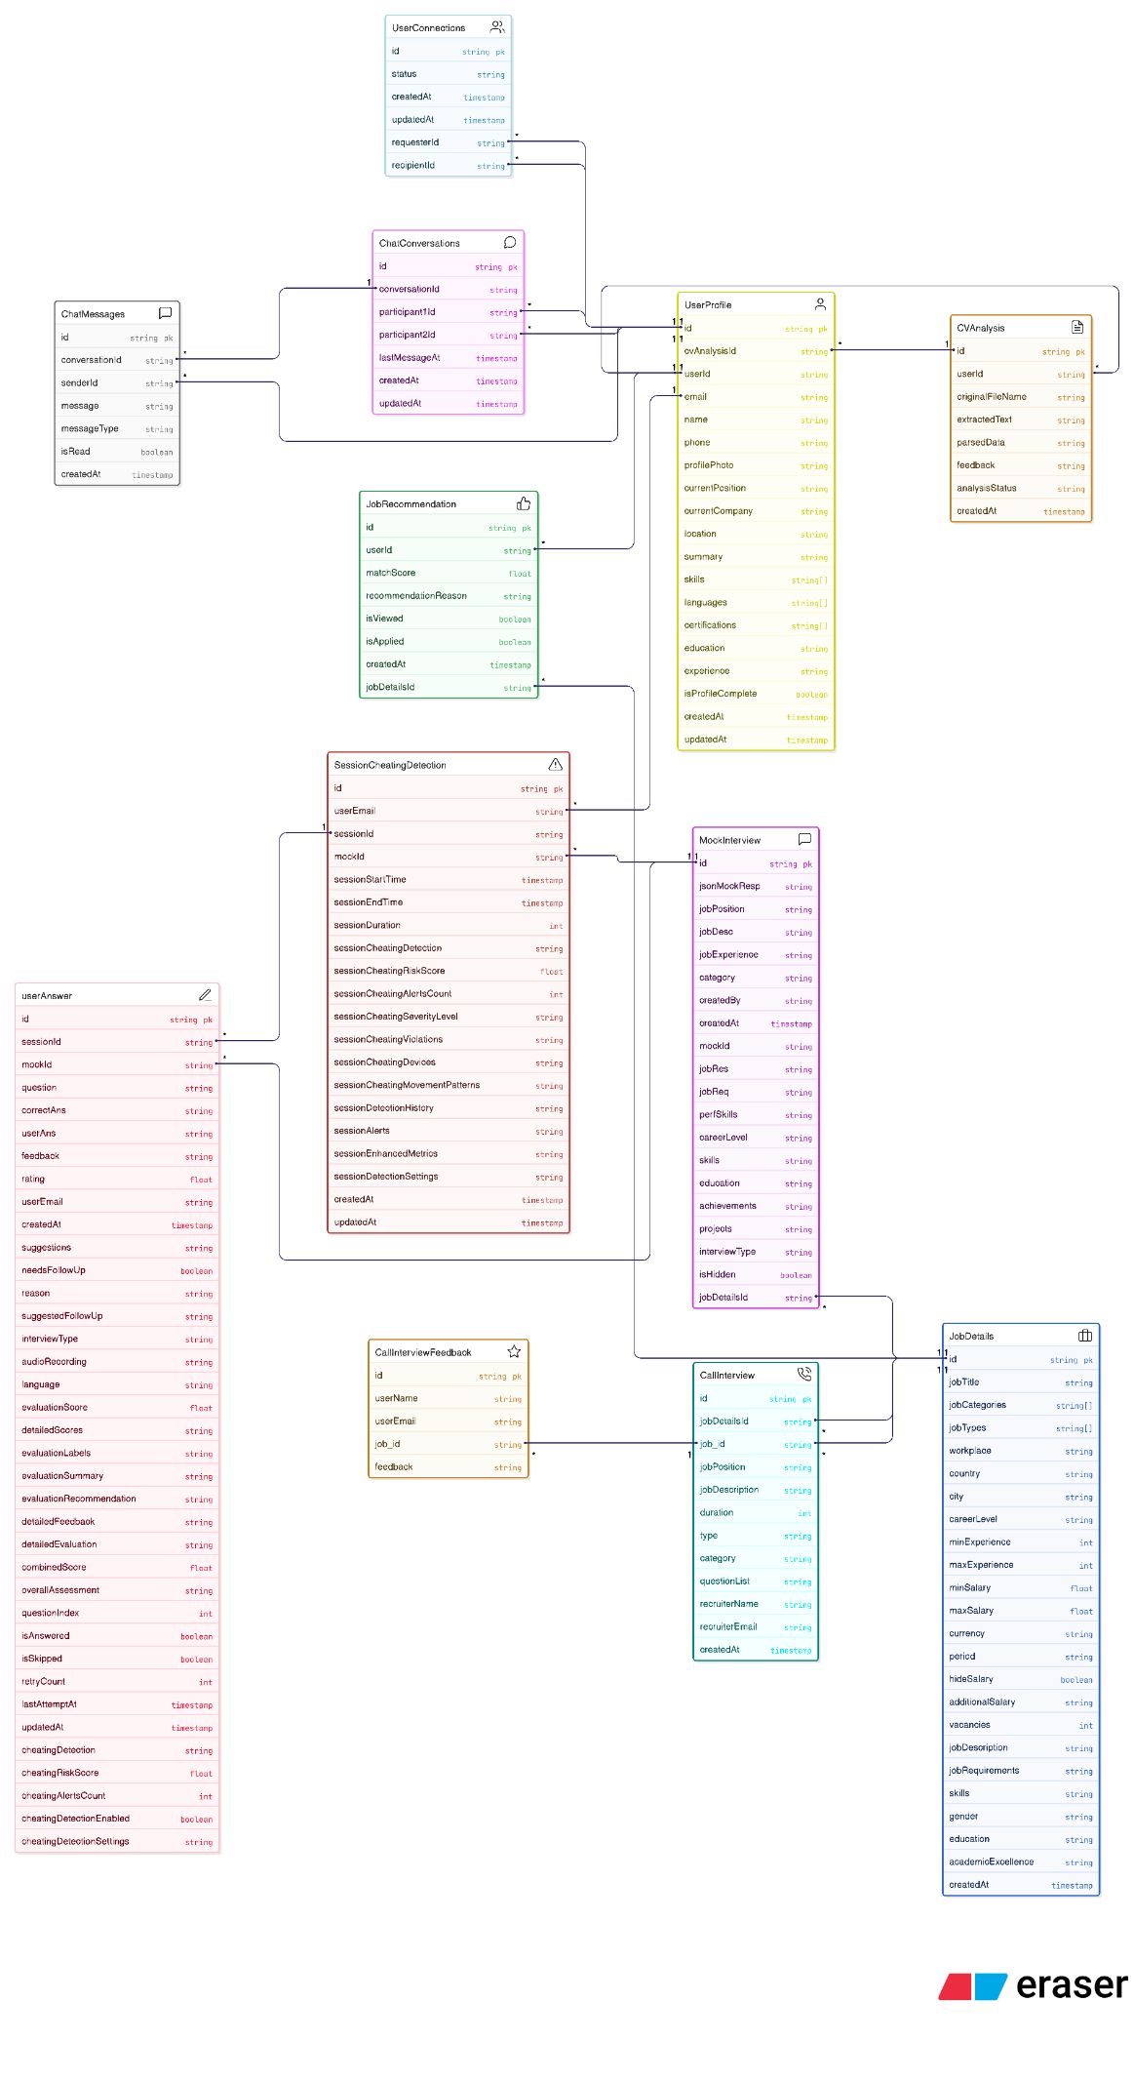

# AI Interview Application - Comprehensive Database Schema Analysis

## Executive Summary

The AI Interview application represents a sophisticated, full-stack platform that combines artificial intelligence, job matching, interview management, and social networking capabilities. Built with Next.js, React, and PostgreSQL, this application serves as a comprehensive solution for both job seekers and recruiters in the modern digital employment landscape.

## Detailed Database Architecture

### Core User Management System

The application's foundation rests on a robust user management system that captures comprehensive professional information:

**UserProfile Table**: This central entity stores detailed user information including:

- **Personal Information**: Name, email (unique), phone, profile photo

- **Professional Details**: Current position, company, location, summary

- **Skills & Competencies**: Arrays of skills, languages, and certifications

- **Experience & Education**: JSONB fields for structured education and work experience data

- **Profile Management**: Completion tracking, creation/update timestamps

**CVAnalysis Table**: Implements AI-powered CV processing with:

- **Document Processing**: Original filename, extracted text from uploaded CVs

- **AI Analysis**: Parsed data in JSONB format containing structured information

- **Feedback System**: AI-generated feedback on CV quality and suggestions

- **Status Tracking**: Analysis completion status and timestamps

The relationship between UserProfile and CVAnalysis is one-to-one, allowing each user to have one comprehensive CV analysis that feeds into their profile.

### Job Management & Matching System

The job management system provides comprehensive job posting and AI-powered matching capabilities:

**JobDetails Table**: Comprehensive job postings with extensive metadata:

- **Basic Information**: Job title, description, requirements

- **Location & Workplace**: Country, city, workplace type (remote/onsite)

- **Compensation**: Salary ranges (min/max), currency, period, hide salary option

- **Requirements**: Experience levels, education, skills, gender preferences

- **Categories**: Job categories and types as arrays for flexible classification

- **Additional Features**: Vacancies, academic excellence requirements, creation timestamps

**JobRecommendation Table**: AI-powered job matching system featuring:

- **Matching Algorithm**: Match scores indicating compatibility between user and job

- **Recommendation Logic**: AI-generated reasoning for job recommendations

- **User Engagement**: Tracking of viewed and applied status

- **Temporal Data**: Creation timestamps for recommendation history

The relationship between JobDetails and JobRecommendation is one-to-many, enabling multiple users to receive recommendations for the same job posting.

### Advanced Interview Management System

The interview system represents the core functionality with sophisticated features:

**MockInterview Table**: Customizable mock interview sessions with:

- **Interview Configuration**: Job position, description, experience requirements

- **Question Management**: JSONB field for structured question lists

- **Customization Options**: Category, interview type, performance skills

- **Content Management**: Job requirements, achievements, projects, education

- **Visibility Control**: Hidden interview options for content management

- **Metadata**: Creation tracking, unique mock IDs, creator information

**userAnswer Table**: Comprehensive answer evaluation system featuring:

- **Question Management**: Individual questions with correct answers and user responses

- **AI Evaluation**: Detailed scoring, feedback, and assessment metrics

- **Advanced Features**: Audio recording support, language detection

- **Evaluation Metrics**: Multiple scoring systems (evaluationScore, combinedScore)

- **Detailed Analysis**: JSONB fields for comprehensive evaluation data

- **Session Management**: Question indexing, retry counts, attempt tracking

- **Cheating Detection**: Risk scores, alert counts, detection settings

- **Follow-up System**: Needs follow-up flags, reasons, and suggested actions

**SessionCheatingDetection Table**: Sophisticated cheating prevention system:

- **Session Tracking**: Start/end times, duration, session IDs

- **Detection Metrics**: Risk scores, alert counts, severity levels

- **Violation Tracking**: Detailed violation records, device monitoring

- **Movement Analysis**: Pattern detection for suspicious behavior

- **Historical Data**: Detection history, alerts, enhanced metrics

- **Configuration**: Customizable detection settings per session

### Real Interview Management

**CallInterview Table**: Real recruiter interview management:

- **Interview Details**: Position, description, duration, type

- **Recruiter Information**: Name, email, contact details

- **Question Management**: Structured question lists in JSONB format

- **Categorization**: Interview categories and types

- **Unique Identification**: Job ID with unique constraints

- **Temporal Tracking**: Creation timestamps

**CallInterviewFeedback Table**: Feedback collection system:

- **User Information**: Name and email of interview participant

- **Feedback Data**: Structured feedback in JSON format

- **Recommendation Tracking**: Boolean recommendation status

- **Job Association**: Links to specific call interviews

### Social Networking & Communication

**UserConnections Table**: Social networking foundation:

- **Connection Management**: Requester and recipient user IDs

- **Status Tracking**: Pending, accepted, rejected, blocked states

- **Temporal Data**: Creation and update timestamps

- **Relationship Management**: Many-to-many user connections

**ChatConversations Table**: Real-time messaging infrastructure:

- **Conversation Management**: Unique conversation IDs

- **Participant Tracking**: Two participants per conversation

- **Activity Monitoring**: Last message timestamps

- **Temporal Data**: Creation and update tracking

**ChatMessages Table**: Message storage and management:

- **Message Content**: Text messages with type classification

- **Sender Tracking**: User ID of message sender

- **Read Status**: Message read/unread tracking

- **Temporal Data**: Creation timestamps for message history

## Advanced Features & Capabilities

### AI-Powered Analytics

The application leverages artificial intelligence across multiple domains:

- **CV Analysis**: Automated parsing and evaluation of uploaded resumes

- **Job Matching**: Intelligent recommendation algorithms based on user profiles

- **Interview Evaluation**: Comprehensive answer assessment with detailed feedback

- **Cheating Detection**: Multi-level security monitoring during interviews

### Security & Integrity

The system implements sophisticated security measures:

- **Session-Level Monitoring**: Real-time cheating detection during interviews

- **Multi-Metric Analysis**: Risk scores, alert counts, severity levels

- **Device Tracking**: Monitoring of multiple devices and suspicious patterns

- **Violation Recording**: Detailed logging of potential security breaches

### Data Management

The database employs modern PostgreSQL features:

- **JSONB Fields**: Flexible storage for complex data structures

- **Array Types**: Efficient storage of skills, languages, and categories

- **Timestamps**: Comprehensive temporal tracking across all entities

- **Auto-incrementing IDs**: Reliable primary key management

- **Unique Constraints**: Data integrity for critical fields

## Technical Architecture

### Database Technology Stack

- **Primary Database**: PostgreSQL with Neon serverless hosting

- **ORM Framework**: Drizzle ORM with TypeScript integration

- **Migration Management**: Drizzle Kit for schema versioning

- **Data Types**: Advanced PostgreSQL features (JSONB, arrays, timestamps)

### Application Architecture

- **Frontend**: Next.js with React components

- **Backend**: API routes with serverless functions

- **Authentication**: NextAuth.js integration

- **File Storage**: Upload handling for CVs and profile photos

- **Real-time Features**: WebSocket support for chat functionality

## Business Logic Domains

### 1. User Experience Management

The application provides a comprehensive user experience with:

- **Profile Completion**: Guided profile building with completion tracking

- **CV Enhancement**: AI-powered analysis and improvement suggestions

- **Skill Assessment**: Automated skill evaluation and recommendations

- **Progress Tracking**: User engagement and completion metrics

### 2. Job Market Integration

The platform serves as a bridge between job seekers and employers:

- **Intelligent Matching**: AI-powered job recommendations based on user profiles

- **Application Tracking**: Comprehensive tracking of job applications

- **Engagement Metrics**: View and application status monitoring

- **Market Analytics**: Job market trends and user behavior analysis

### 3. Interview Excellence

The core interview system provides:

- **Practice Environment**: Mock interviews with customizable questions

- **Real Interview Support**: Call interview management and feedback

- **Performance Analytics**: Detailed evaluation and scoring systems

- **Improvement Tracking**: Progress monitoring and skill development

### 4. Social Professional Network

The platform fosters professional connections:

- **Network Building**: User connections and relationship management

- **Real-time Communication**: Instant messaging between connected users

- **Professional Networking**: Friend requests and status management

- **Community Features**: Social aspects of professional development

### 5. Security & Compliance

Advanced security features ensure platform integrity:

- **Interview Security**: Comprehensive cheating detection and prevention

- **Data Protection**: Secure handling of personal and professional information

- **Session Management**: Robust session tracking and monitoring

- **Compliance**: Adherence to data protection and privacy regulations

## Scalability & Performance

The database design supports high-performance operations:

- **Indexed Queries**: Optimized for common access patterns

- **JSONB Performance**: Efficient storage and retrieval of complex data

- **Array Operations**: Fast processing of skills and category data

- **Temporal Queries**: Efficient timestamp-based operations

- **Relationship Optimization**: Well-designed foreign key relationships

## Future Expansion Capabilities

The database schema is designed for extensibility:

- **Modular Design**: Independent tables allow for feature additions

- **Flexible Data Types**: JSONB fields accommodate new data structures

- **Scalable Relationships**: Many-to-many relationships support complex interactions

- **API-Ready**: RESTful API design for external integrations

- **Analytics Ready**: Comprehensive data collection for business intelligence

## Conclusion

The AI Interview application represents a cutting-edge platform that successfully integrates artificial intelligence, professional networking, and comprehensive interview management. The database schema demonstrates sophisticated design principles with:

- **Comprehensive Coverage**: All aspects of the job search and interview process

- **AI Integration**: Multiple AI-powered features for enhanced user experience

- **Security Focus**: Advanced cheating detection and data protection

- **Social Features**: Professional networking and communication capabilities

- **Scalable Architecture**: Modern database design supporting growth and expansion

This platform serves as a complete solution for modern employment challenges, providing job seekers with tools for skill development, practice, and networking while offering recruiters with intelligent candidate matching and interview management capabilities. The database architecture supports this comprehensive vision with a well-designed, scalable, and secure foundation for continued innovation and growth.

3.8 I-Hire Web Application Interface:  
  
Figure 6: I-Hire | Home

**Page Description:** The I-Hire Home page introduces users to an innovative AI-powered recruitment platform designed to streamline and enhance the hiring process. It highlights the platform’s ability to conduct interviews at scale, reduce unconscious bias, and support data-driven hiring decisions. The page features clear calls to action for both job seekers and employers, emphasizing the platform’s dual focus. With a modern, welcoming design and concise messaging, the Home page sets the stage for a seamless and intelligent recruitment experience.

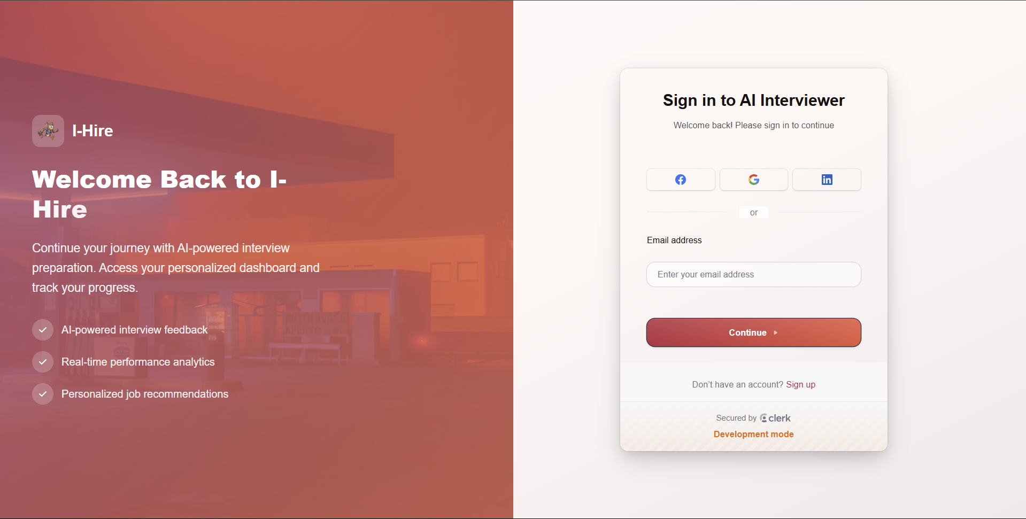

Figure 7: I-Hire | Sign In page



Figure 8: I-Hire | Sign Up page  
  
**Page Description:** Access or create your I-Hire account to unlock AI-powered interview practice, real-time performance insights, and smart job matching. Sign in or join quickly with email or social accounts to start your personalized interview preparation journey.  
  
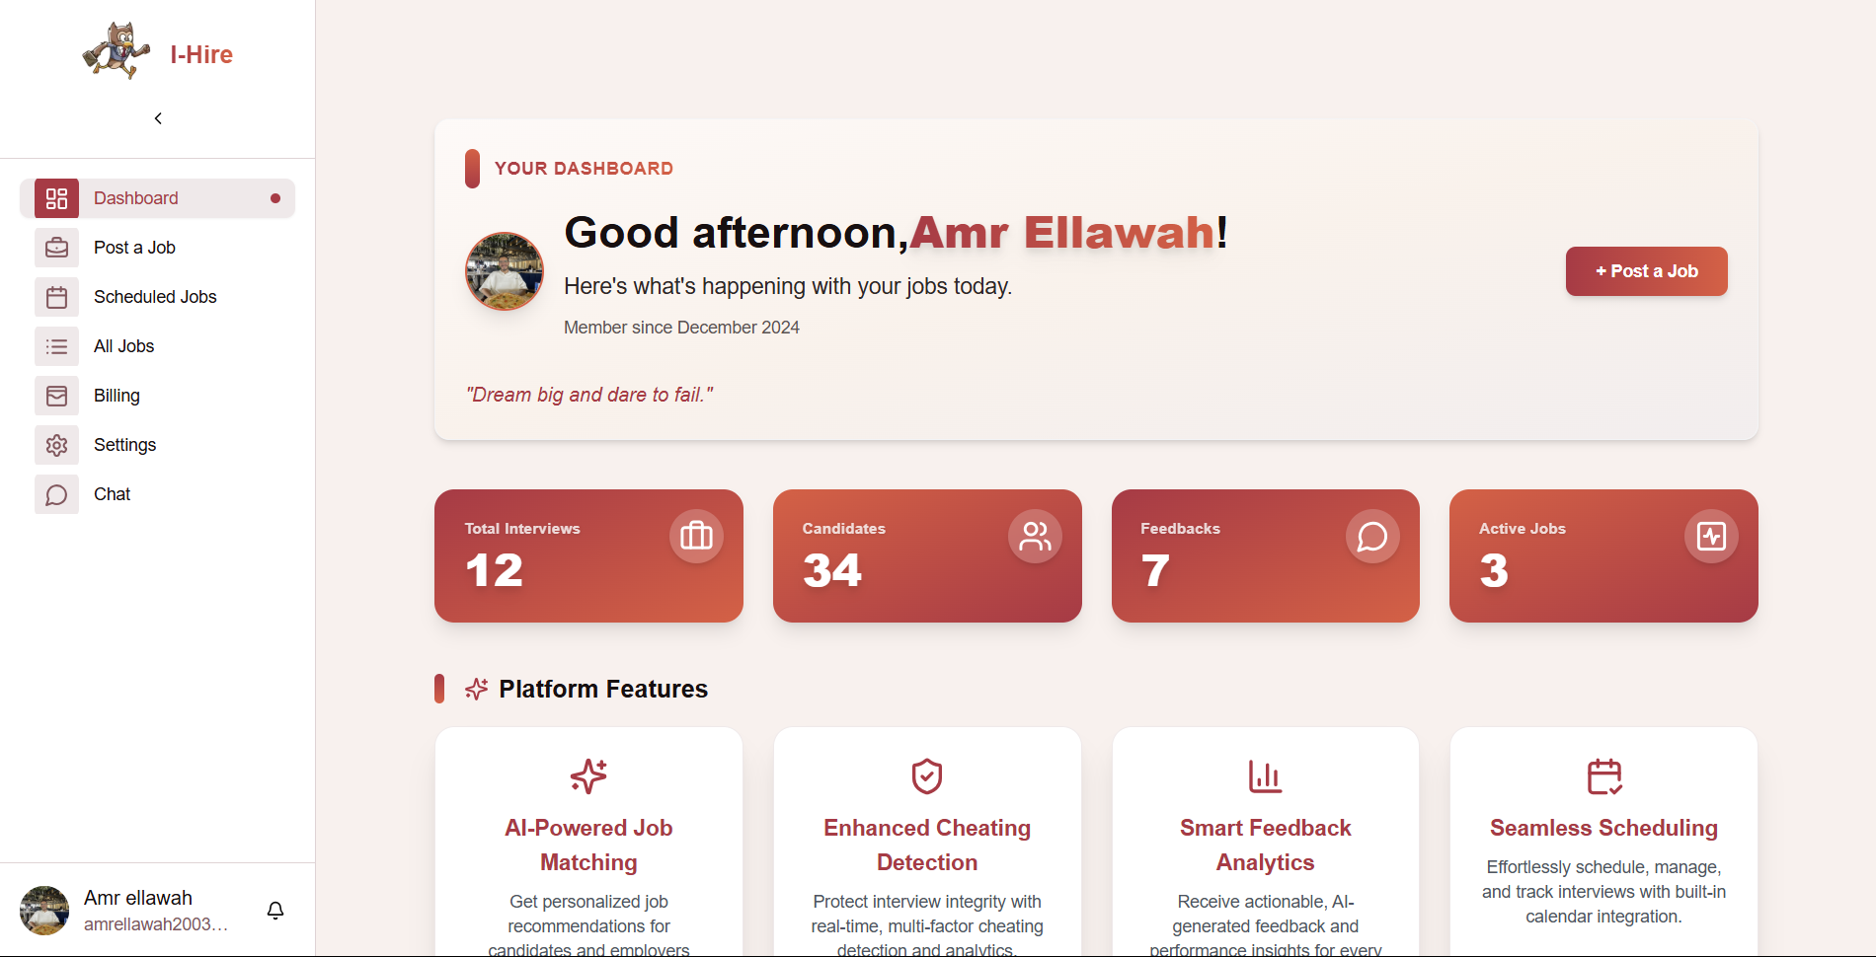  
Figure 9: I-Hire | Recruiter Dashboard Page

**Page Description:** View your personalized dashboard to track interviews, candidates, feedback, and active jobs. Access platform features like AI-powered job matching, cheating detection, smart analytics, and seamless scheduling—all in one place.

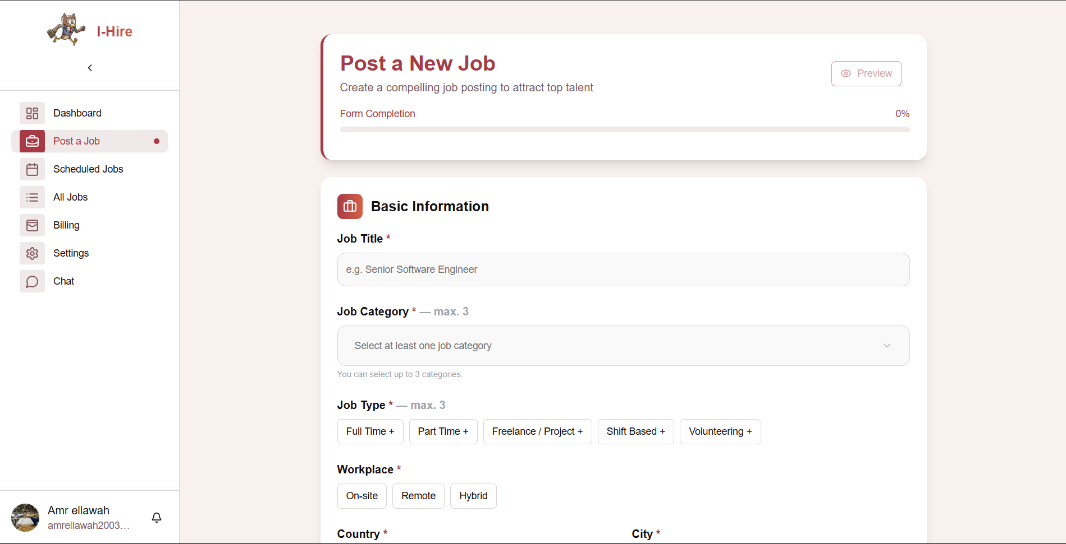 Figure 10: I-Hire | Post a New Job

**Page Description:** Easily create and publish job postings by entering key details like title, category, type, and workplace. Attract top talent with a compelling listing and manage your hiring process efficiently.



Figure 11: I-Hire | Interview Options

**Page Description:** Choose between AI-powered video interviews for in-depth candidate assessment or schedule phone screening calls for quick, initial evaluations before formal interviews.

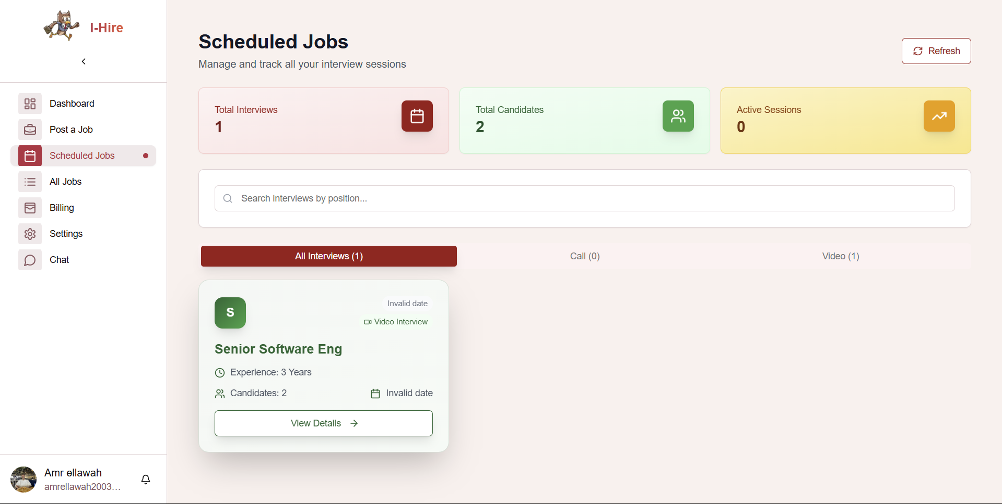

Figure 12: I-Hire | Scheduled Jobs

**Page Description:** Manage and track all your upcoming interview sessions, view candidate details, and monitor interview status in one organized dashboard.

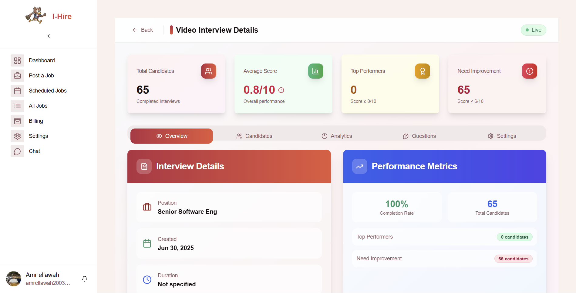

Figure 13: I-Hire | Video Interview Details

**Page Description:** View detailed analytics for a specific video interview, including candidate performance, average scores, top performers, and areas needing improvement. Access interview details, metrics, and insights to optimize your hiring process.

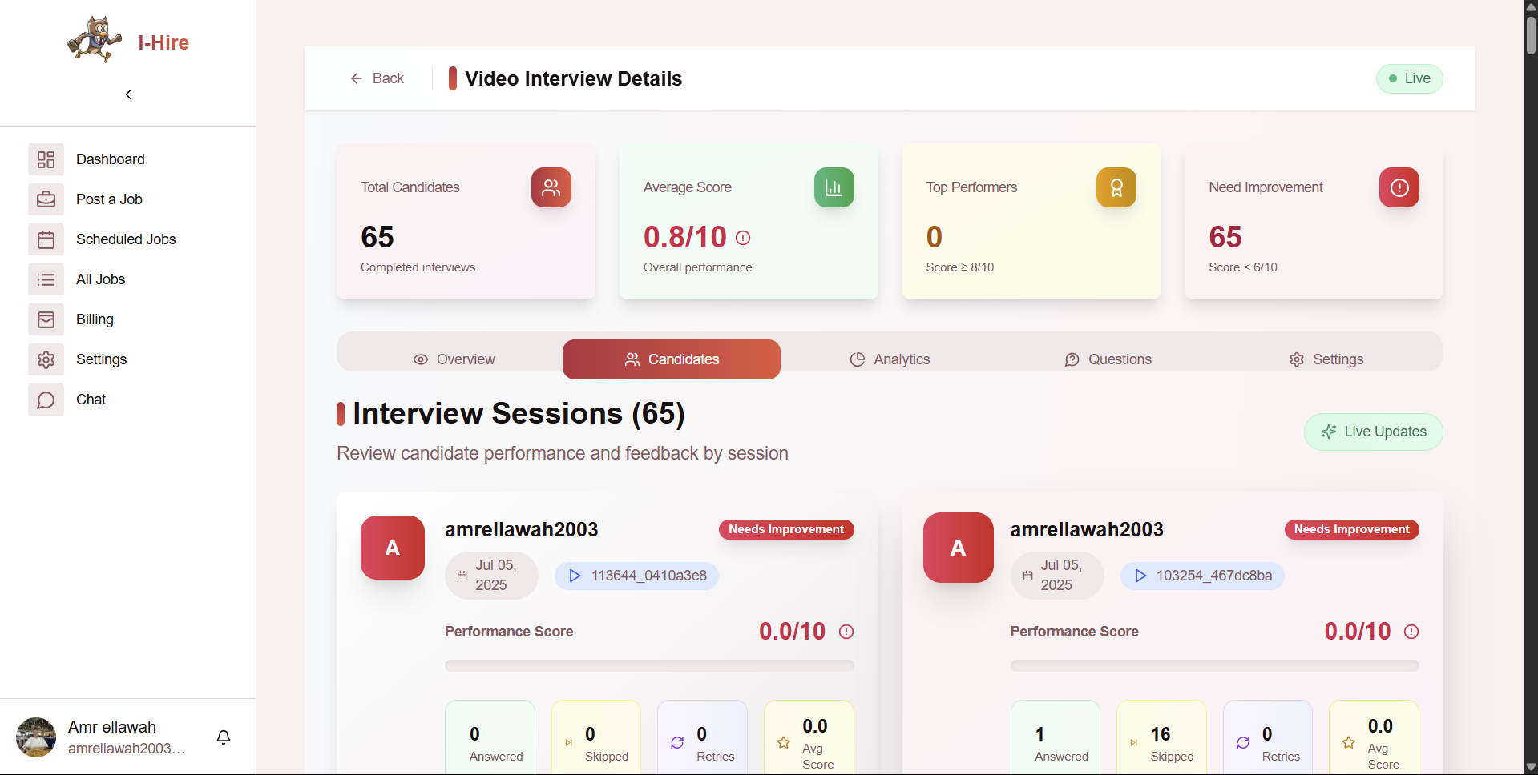

Figure 14: I-Hire | Video Interview – Candidate Sessions

**Page Description:** Review individual candidate performance and feedback for each video interview session. Track scores, progress, and improvement areas to make informed hiring decisions.

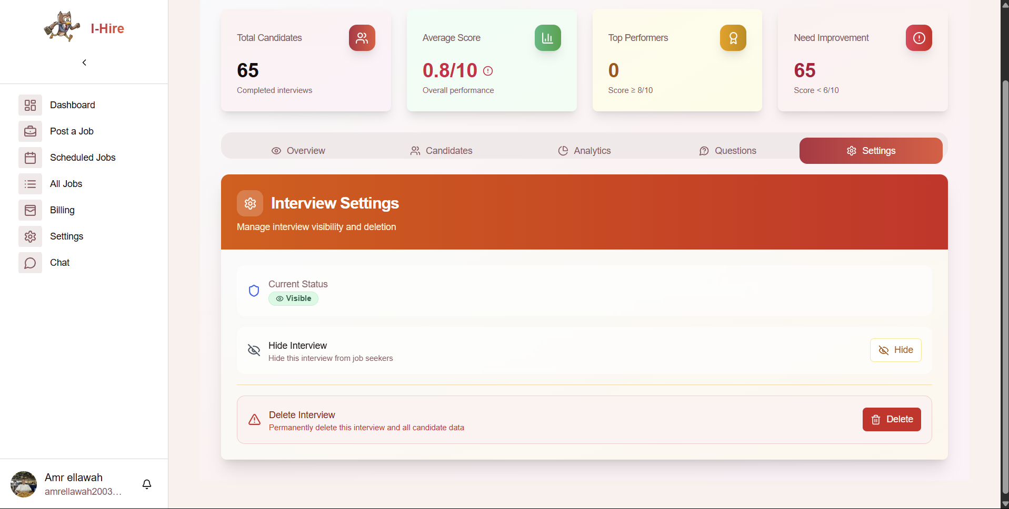Figure 15: I-Hire | Video Interview Settings

**Page Description:**Manage interview visibility and data. Hide interviews from job seekers or permanently delete interview sessions and all related candidate data.

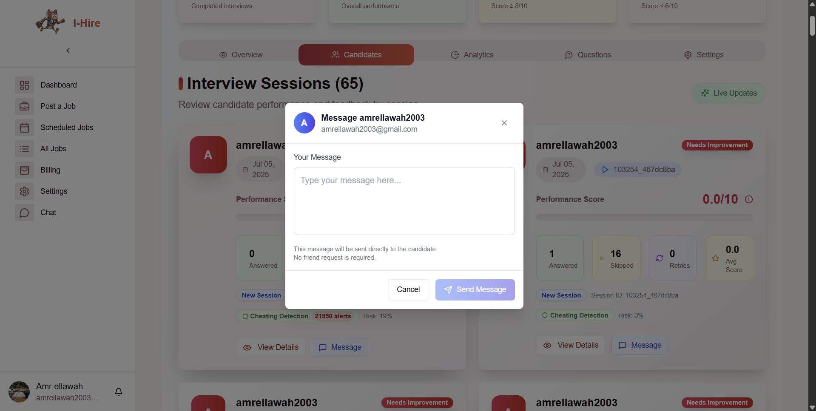

Figure 16: I-Hire | Message Candidate

**Page Description:** Send direct messages to candidates for feedback, updates, or interview follow-up no friend request required.

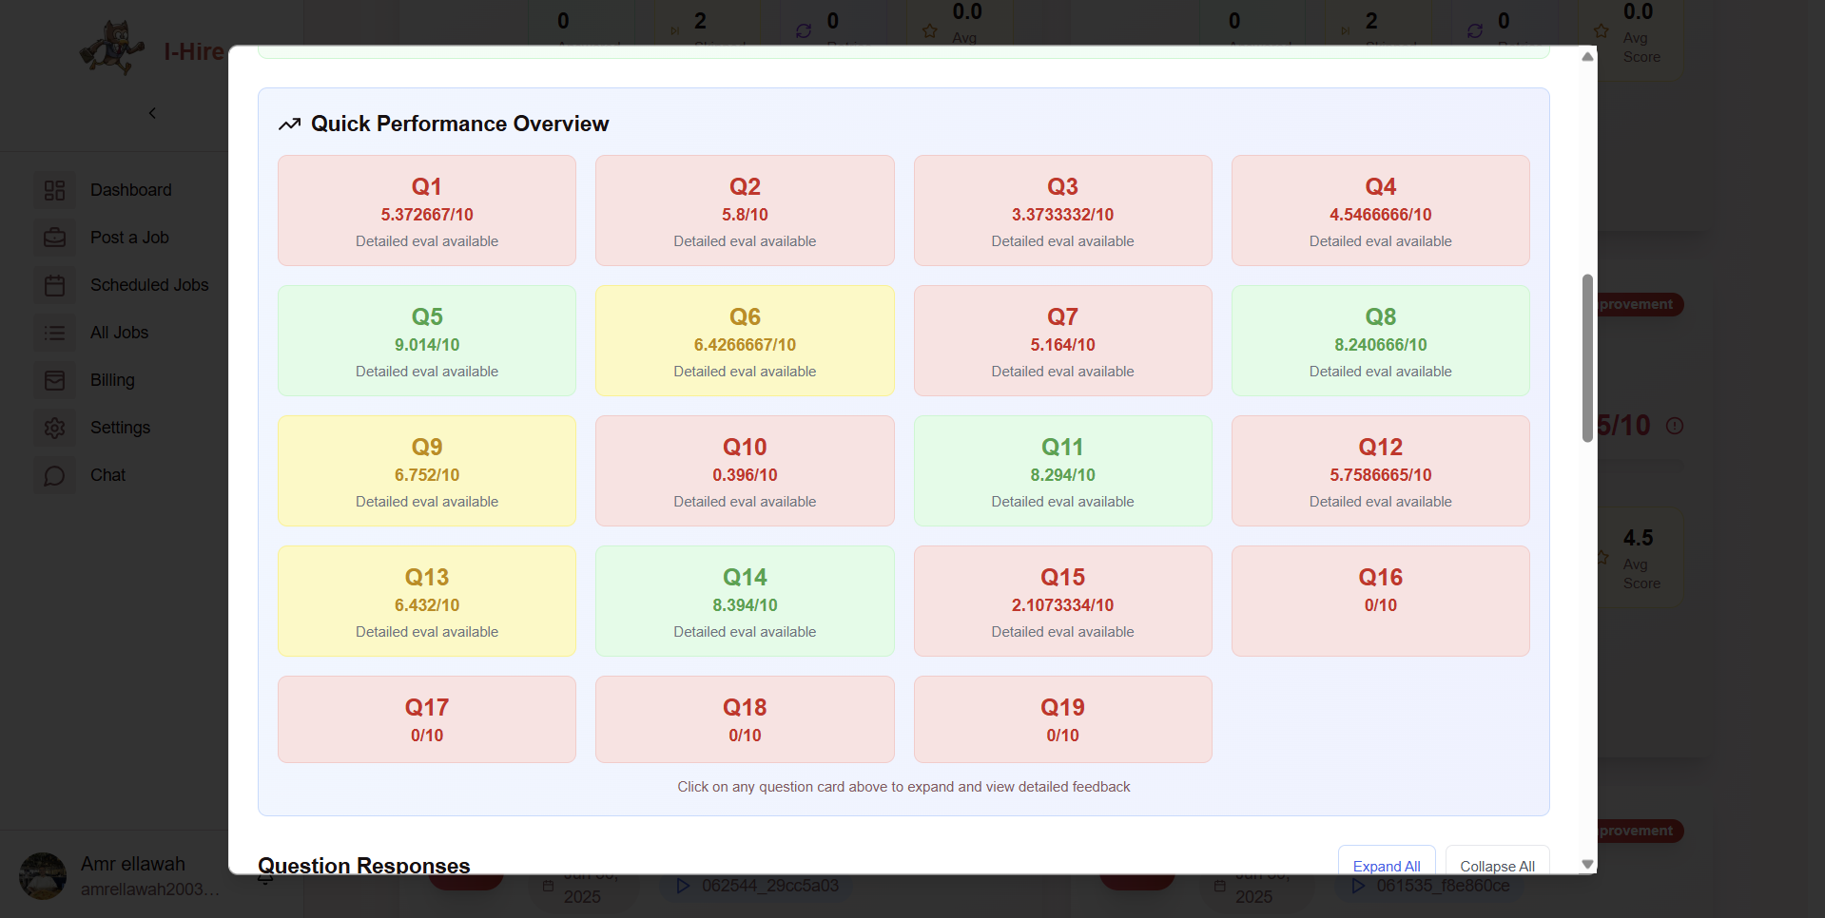Figure 17: I-Hire | Quick Performance Overview

**Page Description:** View a summary of candidate scores for each interview question. Click any question to see detailed feedback and evaluation.

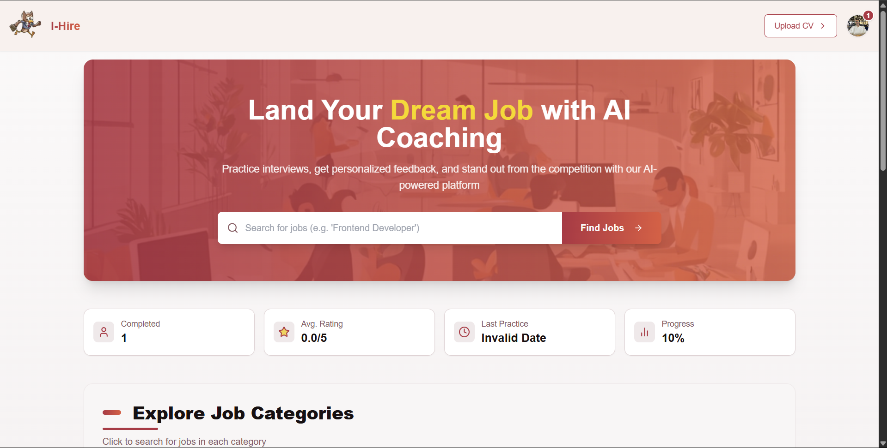

Figure 18: I-Hire | Job Seeker Home

**Page Description:**Practice interviews, get personalized AI feedback, and search for jobs to boost your career. Track your progress and explore job categories tailored to your goals 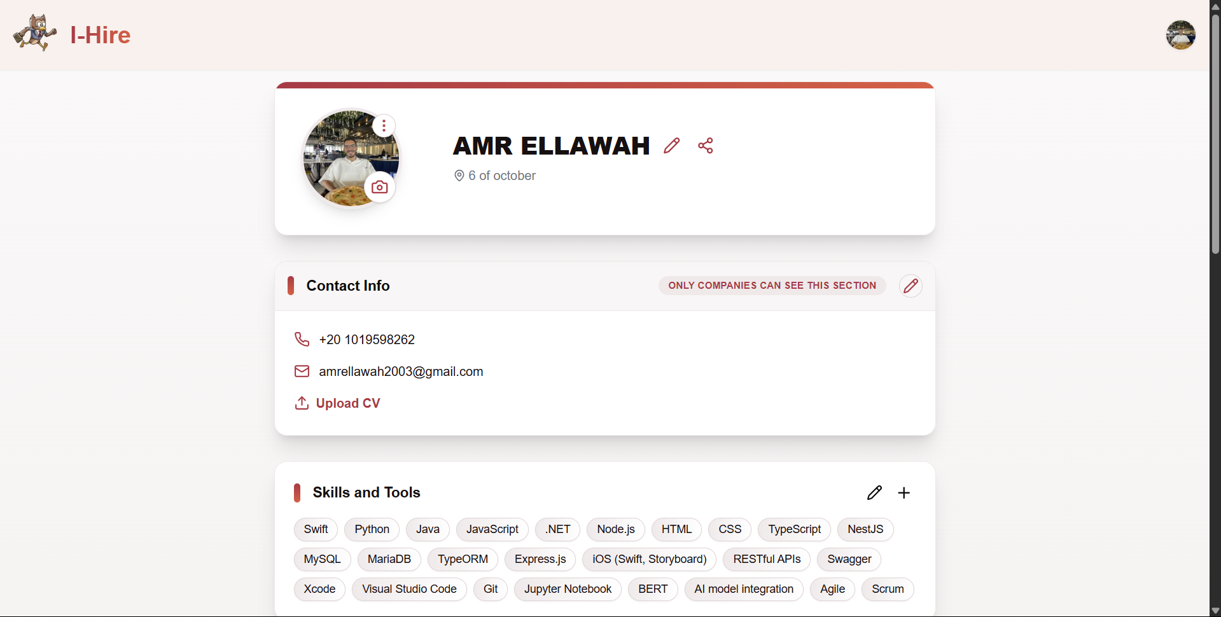Figure 19: I-Hire | Job Seeker Profile

**Page Description:**Showcase your contact information, skills, and tools. Upload your CV and keep your profile updated for companies to discover your talent.

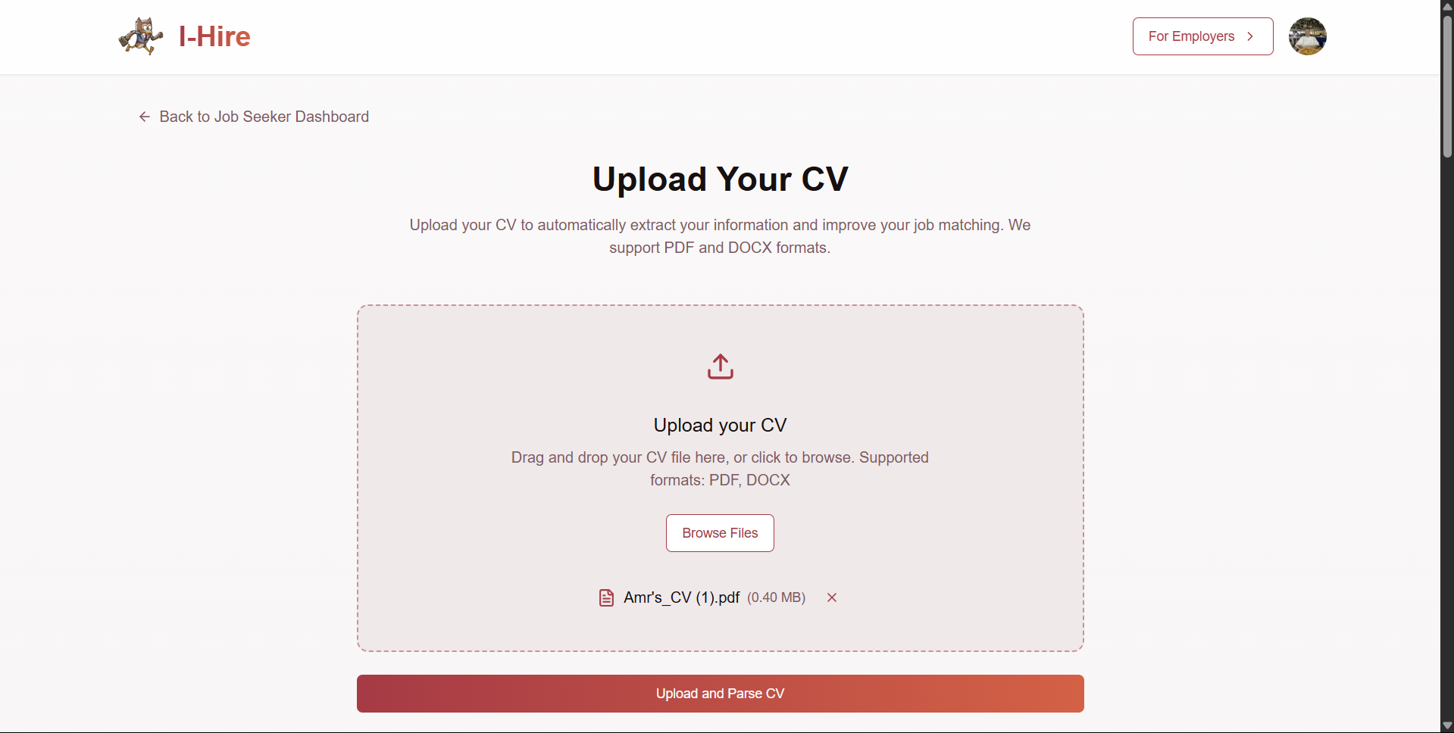Figure 20: I-Hire | Upload Your CV**Page Description:**Easily upload your CV in PDF or DOCX format to extract your information and improve job matching with AI-powered analysis.



Figure 21: I-Hire | Extracted CV Information

**Page Description:** Review and edit your extracted CV details, including personal info, education, and work experience. Download or save the information directly to your profile.

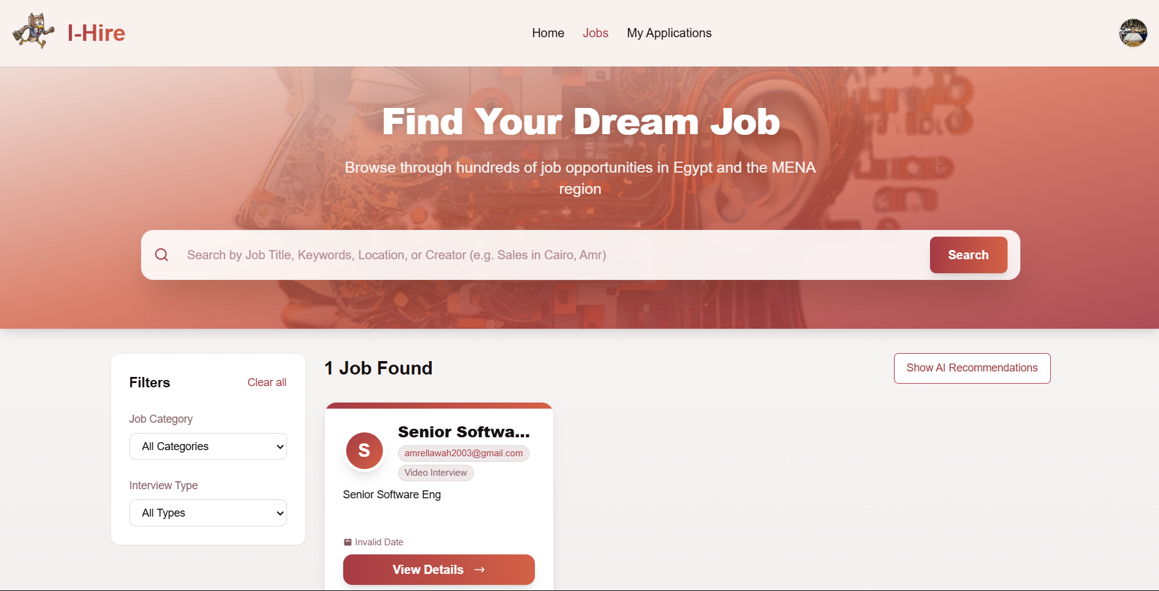Figure 22: I-Hire | Job Search

**Page Description:** Browse and search job opportunities across Egypt and the MENA region. Filter by category or interview type, and view AI-powered job recommendations tailored to your profile.

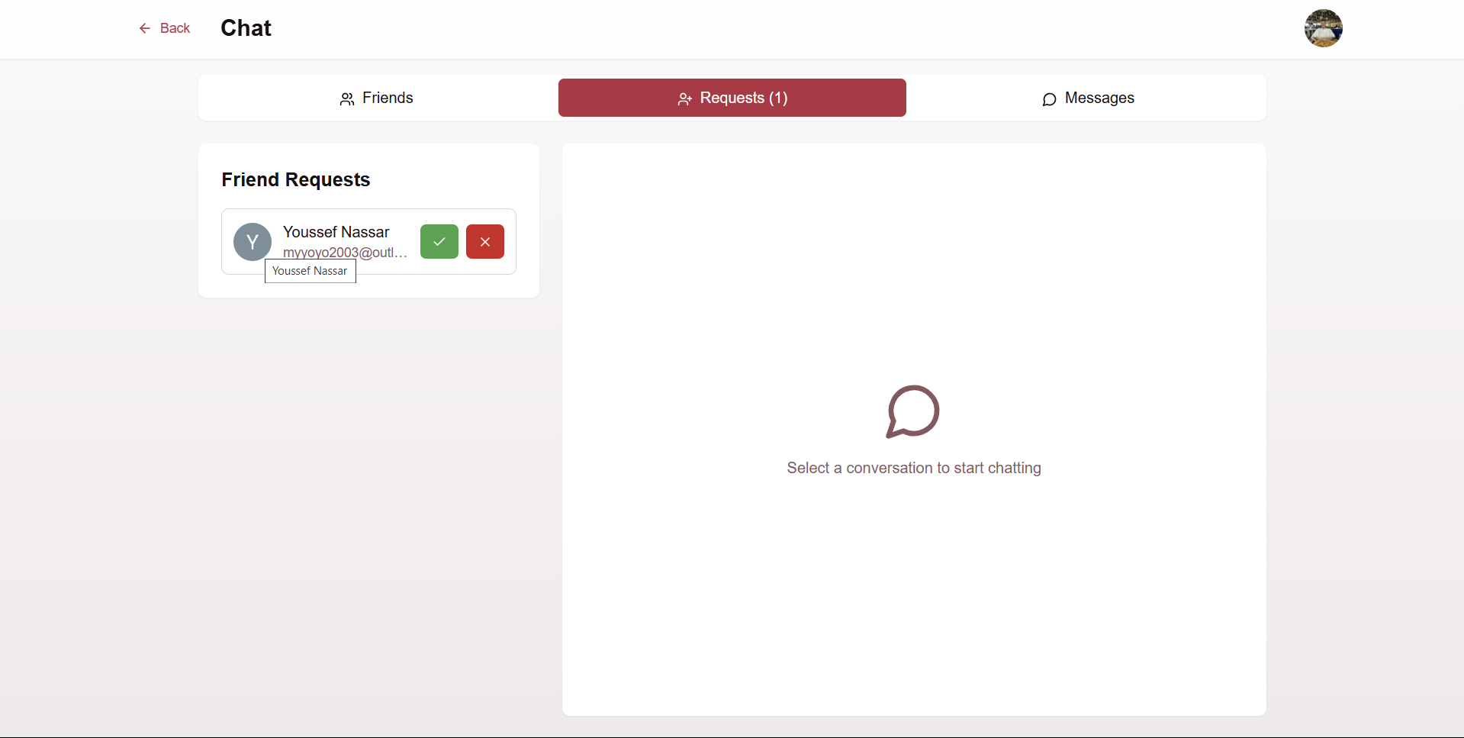

Figure 23:I-Hire | Chat

**Page Description:** Manage friend requests, connect with other users, and start conversations—all in one place.

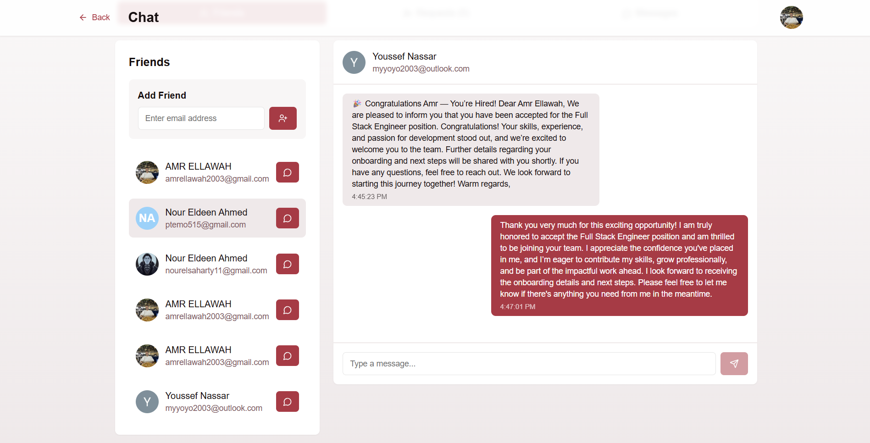

Figure 24: I-Hire | Chat Conversation

**Page Description:** Chat directly with your connections, send and receive messages, and manage your professional network in real time.  
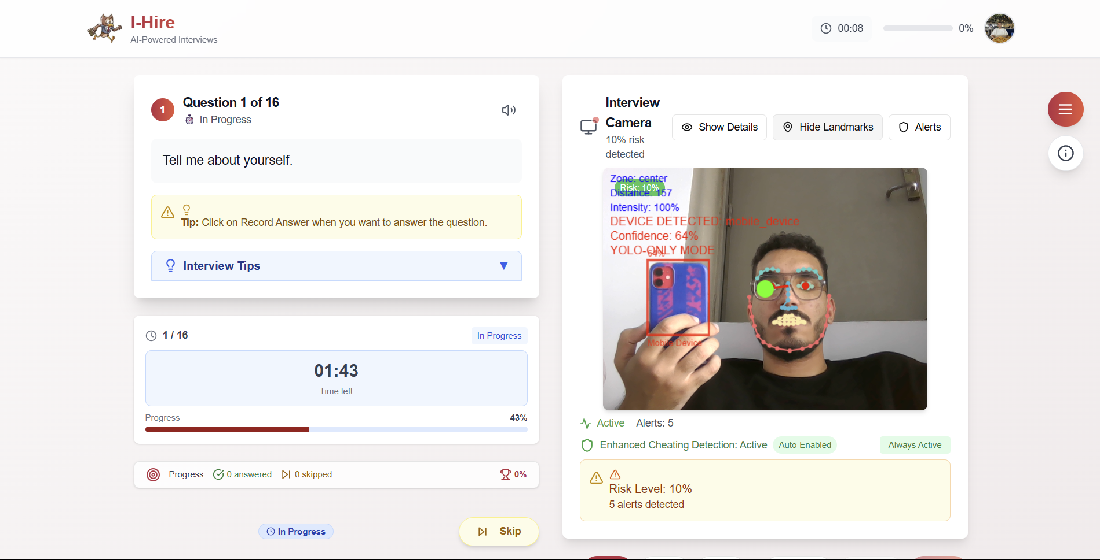

**Page Title:**I-Hire | Live AI Interview**Page Description:**Participate in a real-time AI-powered interview with automated question prompts, answer recording, and live cheating detection for a secure and fair assessment experience.

## Chapter 4: AI and Integrative Solution

This chapter delves into the core Artificial Intelligence (AI) modules strategically employed within the i-hire platform, providing in-depth explanations of their functionalities, implementation details, and seamless integration within the overall system architecture. The selection and fine-tuning of these models were driven by the need to address specific challenges in recruitment, ensuring accuracy, efficiency, and fairness.

# 4.1 Dynamic Question Generation with GPT-4o mini

The I-Hire system utilizes GPT-4o mini, a compact yet high-performance transformer-based Large Language Model (LLM), to enable dynamic, context-aware interview question generation. This approach moves beyond traditional static question banks by generating questions in real time, adapted to the candidate’s profile, prior responses, and the specific job requirements. The system leverages GPT-4o mini’s deep neural architecture to support nuanced and evolving interview dialogues tailored to individual candidates.

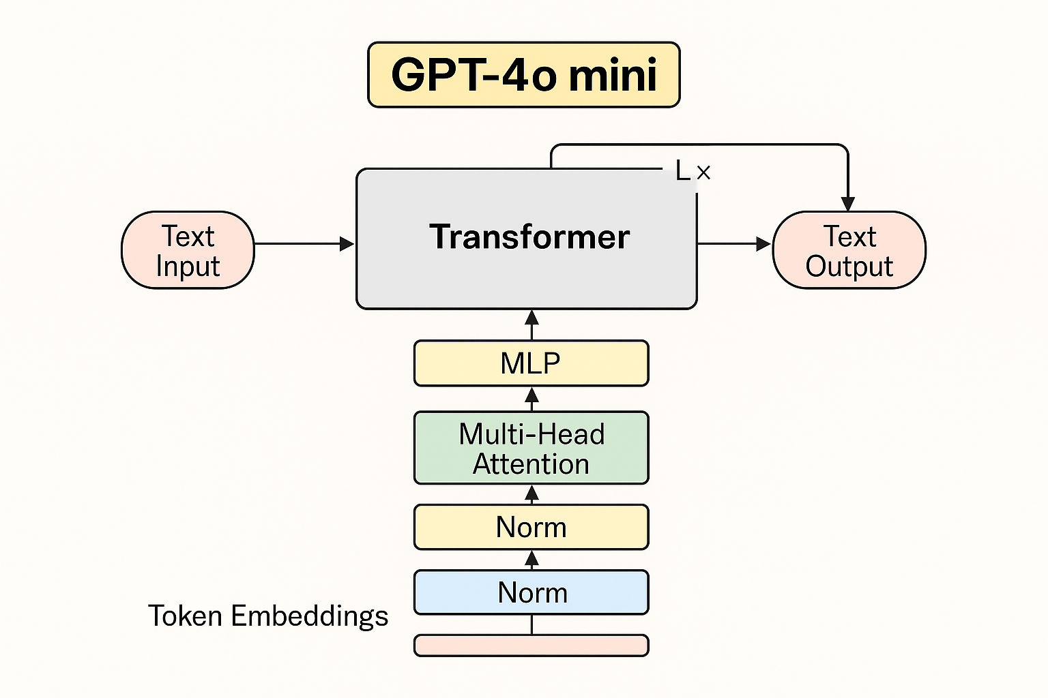

At the architectural level, GPT-4o mini is built on a decoder-only transformer model, comprising multiple layers of multi-head self-attention mechanisms and feedforward networks. These are augmented with rotary positional encodings (RoPE) to effectively handle long-range dependencies within the conversation. The model includes residual connections and layer normalization to maintain stability across extended input sequences. With a context window of up to 32,000 tokens, GPT-4o mini is capable of ingesting entire job descriptions, candidate resumes, and long conversation histories, which makes it highly suited for conversational tasks such as interviews.

A core feature of I -Hire is its structured prompt engineering pipeline, which plays a pivotal role in guiding the model’s outputs. Prompts are designed to include the job description, the candidate's background, and the evolving interview dialogue. The input is formatted into structured segments system instructions, job description, candidate profile, prior Q&A pairs, and a task-specific directive (e.g., "Generate a question to evaluate problem-solving ability"). This structured prompt ensures that GPT-4o mini’s outputs are contextually grounded, semantically coherent, and aligned with both the job requirements and the candidate’s responses.

To support an adaptive interview flow, I-Hire integrates an iterative generation mechanism. After each candidate response, the system appends the new input to the ongoing prompt and re-queries the model for the next question. This creates a feedback loop that allows the system to progressively explore relevant topics, delve deeper into areas of interest, or clarify ambiguous answers. A lightweight flow controller module monitors the interaction for topic drift and ensures balanced coverage of technical, behavioral, and situational competencies. This mechanism can be framed as a partially observable Markov Decision Process (POMDP), where the system updates its internal state based on observed candidate responses and selects the optimal next question accordingly.

Bias mitigation is also central to I-Hire’s design. The prompt templates are constructed to be free from demographic cues, focusing instead on skills, experience, and behaviors. Where candidate profiles contain potentially sensitive information, the system applies masked attention techniques during prompt construction to neutralize such influence. In addition, generated questions are audited by a downstream classifier trained to flag potential bias or off-topic inquiries, using methods such as named entity recognition and topic modeling. This dual-layer mitigation approach, combining proactive prompt constraints with reactive output filtering, helps ensure that the generated questions remain fair, ethical, and compliant with equal opportunity standards.

# 4.2 Candidate Answer Evaluation with GPT-4o

The I-Hire platform employs a label-based evaluation system powered by GPT-4o mini, enabling automated and structured analysis of candidate responses during interviews. This system transforms qualitative, free-form answers into multidimensional feedback using a well-defined set of evaluation labels. By leveraging the advanced reasoning capabilities of GPT-4o mini, the platform provides detailed, context-sensitive feedback that is both scalable and consistent.

At the heart of the system lies a multi-label evaluation framework. For each interview question, candidate responses are assessed across several discrete semantic dimensions, or labels, such as relevance, clarity, technical accuracy, coherence, conciseness, and completeness. Each label is governed by a formal rubric that defines score levels on 0-10 scale along with clear qualitative criteria for each point on the scale. This structured evaluation ensures consistency and comparability across different candidates and interview sessions.

To operationalize this framework, I-Hire implements a prompt engineering strategy tailored to GPT-4o mini. For each candidate response, the prompt includes the original interview question, the answer, and the rubric definitions for each evaluation label. The model is instructed to analyze the response and generate both numerical scores and brief explanations for each label. This approach enables GPT-4o mini to simultaneously evaluate the response across multiple dimensions, providing fine-grained, interpretable feedback. The model processes these inputs using its transformer architecture, were multi-head self-attention layers jointly

analyze the relationship between the question, the response, and the rubric definitions. Its ability to maintain coherence over long prompts ensures that the full context is preserved during evaluation.

The system is designed with modular architecture, composed of several layers. The first is the input encoding layer, which formats the inputs into a prompt sequence suitable for GPT-4o mini. The second is the inference layer, where the LLM generates structured outputs containing scores and justifications. These outputs are then passed to a post-processing layer, which parses the responses into structured formats like tables or JSON for further analysis. Additionally, optional logic can flag low-scoring answers or inconsistencies for review. The final layer is the dashboard or API interface, where evaluation results can be visualized, exported, or integrated into candidate ranking pipelines.

This architectural design brings several advantages. By evaluating responses across multiple independent labels, the system ensures modularity, allowing custom evaluation dimensions to be added or removed as needed. The use of rubrics provides interpretability, as each score is accompanied by a clear rationale. The model’s efficiency, coupled with its long-context handling and lower computational footprint compared to full-sized GPT-4, makes it suitable for high-throughput scenarios like large-scale hiring campaigns. Moreover, the structured outputs can feed directly into downstream analytics for performance benchmarking or feedback generation.

Looking ahead, I-Hire aims to enhance this system with features such as few-shot learning, where GPT-4o mini is provided with example evaluations to improve alignment with recruiter preferences. Plans also include support for multilingual evaluations and meta-evaluation layers to monitor consistency and detect rubric ambiguities. These enhancements will make the system even more robust, adaptable, and inclusive.

# 4.3 Speech-to-Text Transcription with Fine-tuned Whisper medium

Accurate transcription of spoken responses is a critical component of the I-Hire platform, forming the foundation upon which all subsequent AI-driven evaluation and analysis are built. To meet this requirement, I-Hire integrates a fine-tuned version of Whisper Medium, a state-of-the-art automatic speech recognition (ASR) model developed by OpenAI. Whisper Medium strikes an ideal balance between accuracy and efficiency, making it particularly well-suited for real-time, large-scale deployment in interactive interview settings.

Whisper Medium is part of the Whisper family of encoder-decoder transformer models trained on hundreds of thousands of hours of multilingual and multitask supervised audio data. Architecturally, it features a series of convolutional and attention-based encoder layers that convert raw log-Mel spectrograms into latent representations, followed by a decoder that generates transcriptions in natural language. The Medium variant includes fewer parameters than the large language model (769M vs. 1.5B), allowing for faster inference without a significant drop in transcription accuracy, especially when fine-tuned on domain-specific data.

I-Hire extends the capabilities of Whisper Medium through a targeted fine-tuning process designed to adapt the model to the unique challenges of interview environments. While the base Whisper models are highly capable, their performance can degrade in niche use cases such as interviews, where speech often includes domain-specific terminology, hesitations, varied emotional tones, and spontaneous corrections. To overcome this, I-Hire constructs a custom fine-tuning dataset composed of real or simulated interview recordings. These recordings cover a broad range of conditions, including diverse English accents, variable audio quality (microphone types, reverberation, background office noise), and a mix of technical and non-technical vocabulary.

During fine-tuning, the model is trained using supervised learning where the input is a log-Mel spectrogram and the target output is the correct transcription. The training objective is to minimize the cross-entropy loss between the predicted and ground-truth token sequences. Data augmentation techniques such as random time shifts, noise injection, and pitch modulation are used to improve generalization and robustness. As a result, the fine-tuned Whisper Medium model achieves significantly lower word error rates (WER) in interview-specific tasks compared to its vanilla counterpart, making it more reliable for real-world deployment.

The transcription module is also optimized for real-time performance, enabling near-instantaneous conversion of spoken responses into textual format. This is critical in interactive interview scenarios, where follow-up questions are generated dynamically based on the most recent answer. Latency is minimized through efficient batching, on-device inference (when supported), and lightweight post-processing. The real-time capability also supports features such as live subtitle generation, interviewer dashboards, and adaptive feedback, enhancing the overall candidate experience.

Once transcribed, the textual output becomes the primary input for downstream AI components within I-Hire. These include the GPT-4o mini evaluation engine, which assesses the quality of responses across structured rubric dimensions, as well as semantic parsing modules for keyword extraction, behavior classification, and intent analysis. The fidelity of the transcription directly impacts the validity of these assessments; hence, ensuring transcription quality is not just a technical requirement but a foundational necessity for the system’s fairness, explainability, and compliance with ethical AI principles.

In addition to its technical merits, Whisper Medium also aligns with I-Hire’s goals for scalable deployment. Due to its moderate size and optimized architecture, the model can be hosted in cloud or edge environments, enabling both centralized processing for large-scale assessments and decentralized, privacy-preserving configurations for on-premises use by enterprise clients.

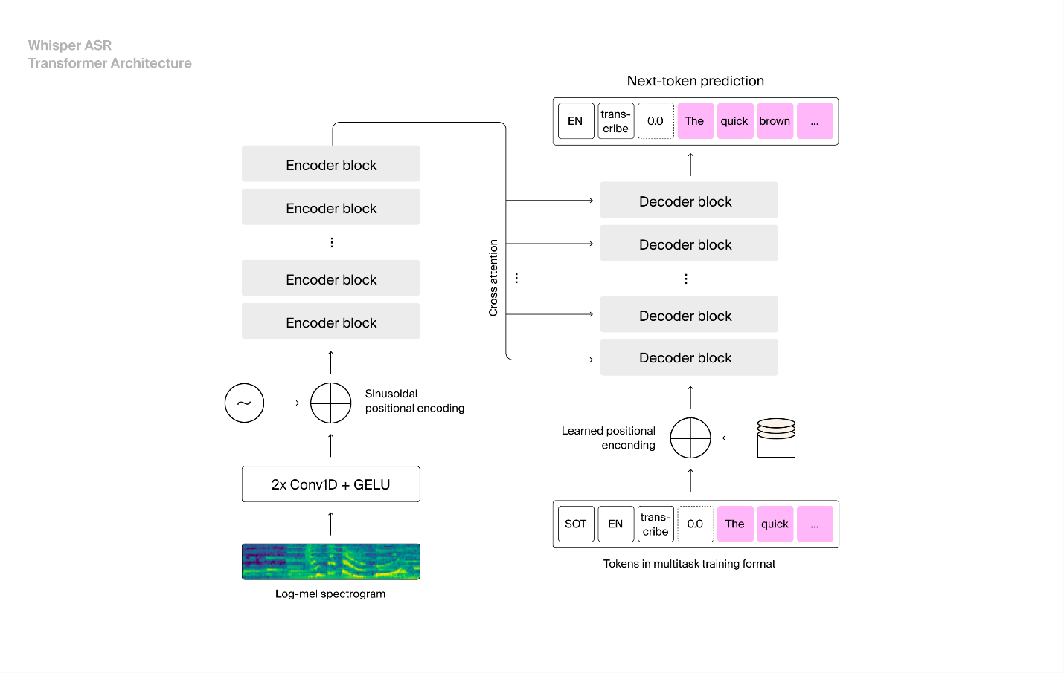

Whisper ASR Transformer Architecture

The Whisper ASR model employs a sequence-to-sequence Transformer architecture designed for multilingual automatic speech recognition and speech translation. The model comprises two primary components: an encoder that processes audio input and a decoder that generates transcribed text. The architecture functions as follows:

**Audio Preprocessing:**

The input to the model is a log-Mel spectrogram, which represents the audio signal in both time and frequency domains. This spectrogram is passed through two 1D convolutional layers followed by GELU (Gaussian Error Linear Unit) activations to extract local temporal patterns and reduce the temporal resolution.

**Positional Encoding for Encoder:**

To capture the sequential nature of speech, sinusoidal positional encodings are added to the output of the convolutional layers. These encodings allow the model to understand the position of each frame in the sequence, which is essential for maintaining temporal order.

**Encoder Stack:**

The processed spectrogram is passed through multiple Transformer encoder blocks, each consisting of multi-head self-attention mechanisms and feedforward neural networks. The encoder produces a sequence of contextualized embeddings representing the entire input audio.

**Decoder Input:**

The decoder is autoregressive and takes as input a sequence of tokens in a multitask training format, including:

* SOT (Start of Transcript),
* Language ID (e.g., EN),
* Task label (e.g., transcribe or translate),
* Timestamp (0.0), and
* Previously generated text tokens (e.g., "The", "quick").

These tokens are embedded and augmented with learned positional encodings to retain order information.

**Decoder Stack:**

The input tokens are passed through several Transformer decoder blocks. Each block contains:

* Masked self-attention to capture dependencies among previously generated tokens,
* Cross-attention to incorporate relevant information from the encoder output,
* Feedforward layers for transformation and learning hierarchical patterns.

**Next-Token Prediction:**

The decoder generates one token at a time, conditioned on the encoded audio and previously generated tokens. This continues until an end-of-transcript token is produced or a predefined length is reached.

# 

# 4.4 Intelligent Job Recommendation with Fine-tuned SBERT

To intelligently match candidates with suitable job opportunities, I-Hire incorporates a fine-tuned Bidirectional Encoder Representations from Transformers (BERT) model. This module forms the core of the platform’s job recommendation engine, leveraging BERT’s powerful contextual language understanding to go far beyond traditional keyword-based matching. By aligning candidate profiles and interview data with job descriptions at a semantic level, this system ensures recommendations are both relevant and personalized.

BERT, a deep bidirectional transformer model pretrained on large corpora of English text, is particularly well-suited for this task due to its ability to encode the meaning of words in context. The model is fine-tuned on a dataset specifically curated for job-candidate matching, including annotated pairs of candidate profiles, interview responses, and job postings. During fine-tuning, the model learns to map both job descriptions and candidate representations into a shared embedding space, enabling semantic similarity comparisons. This allows the system to capture nuanced relationships such as synonym, role equivalence, and implicit experience relevance, which are often missed by surface-level string matching algorithms.

A key strength of the recommendation engine is its ability to perform semantic matching. Rather than relying solely on the presence of exact terms, the BERT model understands deeper linguistic relationships. For example, a candidate describing experience with “data pipelines in cloud environments” can be accurately matched with a job requiring “ETL engineering in AWS,” even if there is little lexical overlap. This context-aware approach ensures that candidates are evaluated on what they mean, not just what they say, reducing false negatives in job matching.

The model also supports personalized recommendations by incorporating features derived from historical behavior and interview performance. Candidate embeddings are enriched with information extracted from their resumes, prior job applications, and even real-time analysis of spoken responses. By combining static qualifications with dynamic performance signals, the model learns to align job recommendations with each candidate’s unique strengths, aspirations, and trajectory. This adaptive learning framework is particularly effective in identifying non-obvious opportunities that still fit well with the candidate’s background and goals.

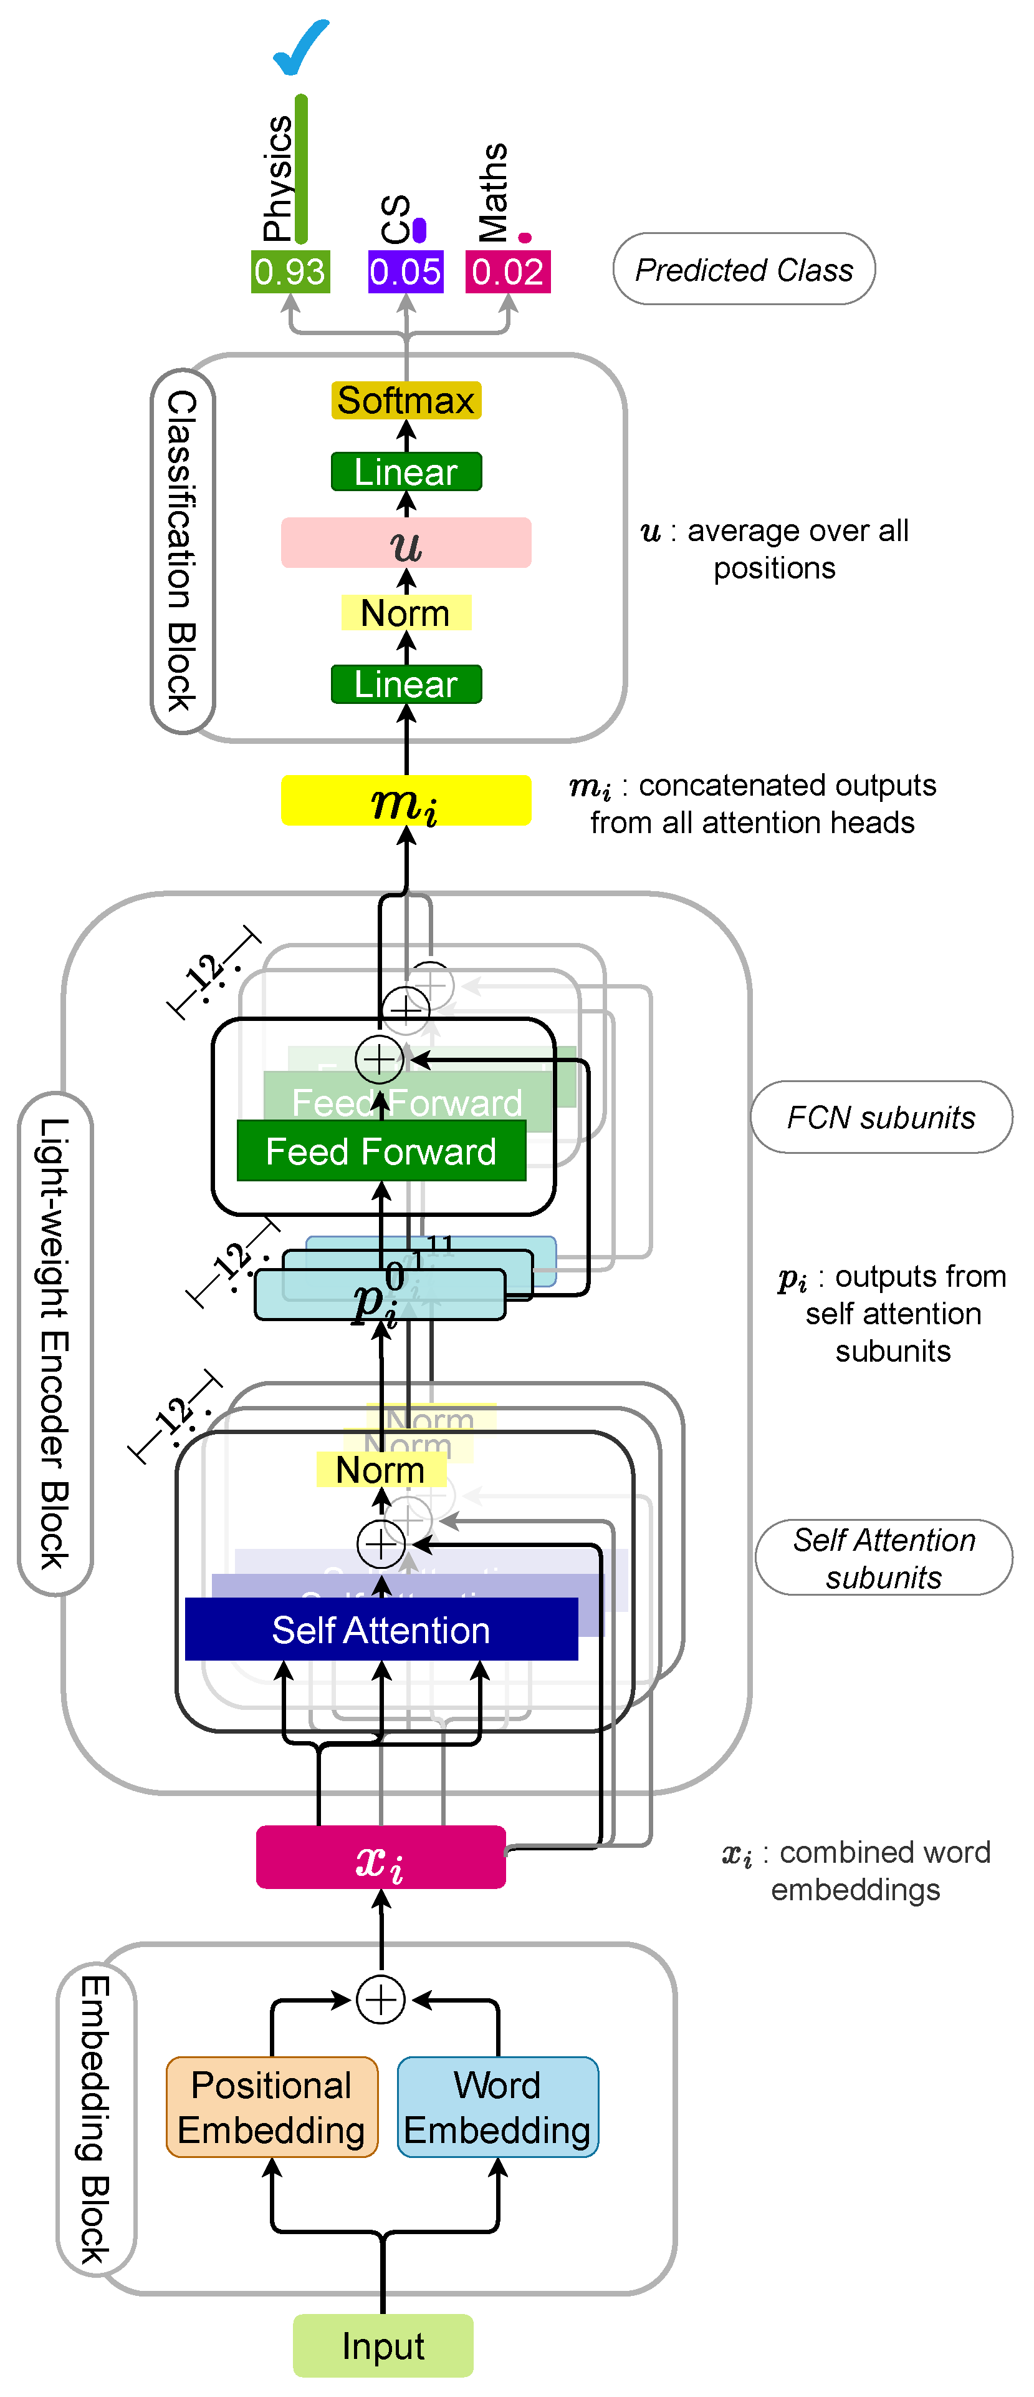

**Sentence-BERT (SBERT) Architecture**

**Sentence-BERT (SBERT)** is a transformer-based architecture designed to generate semantically meaningful sentence embeddings. Unlike the original BERT model, which is optimized for token-level predictions and sentence-pair classification, SBERT enables efficient computation of sentence similarity and classification by mapping entire sentences to fixed-length dense vectors. This design is particularly advantageous for tasks such as semantic textual similarity (STS), clustering, and information retrieval, where fast and accurate comparison between sentence-level inputs is required.

The SBERT model begins with an **embedding block** that combines word and positional embedding. Each input sentence is first tokenized and passed through a word embedding layer that captures semantic content. To preserve the sequential structure of the sentence, positional embeddings are added, allowing the model to understand the order of tokens. The resulting embeddings are summed to form the combined input representations, denoted xix_ixi​, which are then passed into the encoder block.

At the core of SBERT lies a **lightweight Transformer encoder block**, which processes the sentence to build contextual representations for each token. The encoder contains stacked self-attention and feedforward subunits. The self-attention mechanism allows each token to attend to all other tokens in the sequence, thereby capturing contextual dependencies across the sentence. The outputs from this layer are then refined using feedforward subunits, with residual connections and layer normalization applied to stabilize training and improve generalization. The outputs from multiple attention heads are concatenated to form mim_imi​, a high-dimensional representation of the input sentence.

To transform these token-level outputs into a fixed-size **sentence embedding**, SBERT applies **mean pooling** across all token positions. This operation produces a single vector uuu that summarizes the overall meaning of the sentence. In classification tasks, this embedding is passed through a linear layer followed by a softmax activation function to produce class probabilities. As illustrated in the diagram, the model confidently predicts the class "Physics" with a probability of 0.93, compared to much lower probabilities for alternative classes such as "CS" or "Maths".

Importantly, I-Hire’s BERT-based system prioritizes objective factors in its matching criteria. Skills, certifications, technical experience, and other quantifiable qualifications are explicitly extracted and weighted during the recommendation process. This helps mitigate bias by focusing the matching algorithm on meritocratic criteria, avoiding over-reliance on heuristic filters or demographic proxies. Moreover, transparency is enhanced through explainable AI techniques, allowing the system to provide interpretable justifications for why specific jobs were recommended.

# 4.5 Integration and Orchestration

The seamless integration and orchestration of these diverse AI modules are critical to i-hire’s functionality. The Node.js/JavaScript backend acts as the central hub, managing the flow of data between the frontend, the database, and each AI service. This ensures that each module operates in concert, contributing to a unified and efficient recruitment workflow. The API-driven communication between components allows for flexibility, scalability, and the potential for future integration of additional AI capabilities.

## Chapter 5: Methodology

The development of the i-hire platform involved a comprehensive full-stack implementation process, integrating advanced AI modules with robust web technologies. This section details the architectural design, the specific technologies employed, and the systematic approach taken to ensure the platform’s functionality, scalability, and adherence to academic rigor.

# 5.1 Full-Stack Implementation

# 5.1.1 Frontend Development

The user-facing layer of the I-hire platform is architected using React, a declarative, component-based JavaScript library designed for building efficient and scalable user interfaces. React was selected due to its strong capabilities in managing dynamic UI states, its widespread adoption in industry, and its support for modular, reusable components. These characteristics have allowed our development team to build an interface that is not only responsive and fast but also maintainable and extensible as the platform evolves.

The frontend plays a critical role in shaping the user experience for both candidates and recruiters. For candidates, the interface serves as the main portal through which they engage with the interview process. It features an intuitive layout designed to reduce friction and anxiety, presenting questions in a conversational format with minimal distractions. The interface supports multimedia inputs, displays real-time transcriptions and feedback, and allows candidates to navigate through interview stages seamlessly. Candidates also receive personalized dashboards, where they can view job recommendations powered by AI, read structured feedback, and track their progress over time.

On the recruiter side, the frontend provides a robust dashboard environment that supports job management, candidate tracking, and interview configuration. Recruiters can create and edit job postings, set parameters for AI-generated questions, and monitor candidate performance through AI-generated evaluations and visual analytics. Filtering tools, search functionality, and sortable evaluation metrics enable recruiters to efficiently sift through candidates based on job fitness, performance, and skill alignment. The UI is designed to simplify complex workflows, allowing recruiters to manage a high volume of interviews with ease.

One of the core strengths of the frontend architecture lies in its support for real-time interaction with backend AI systems. Using asynchronous communication via WebSockets and RESTful APIs, the frontend can receive dynamically generated interview questions, stream transcriptions as they are produced, and display GPT-generated feedback in near real-time. This immediate responsiveness is critical in maintaining the fluidity and natural rhythm of AI-led interviews, mimicking the pacing of live human interviewers.

From a technical standpoint, the frontend integrates state management tools such as Redux and React Context to handle UI state and user data across components, ensuring consistency and efficiency. For routing, React Router is employed to manage navigation between candidate and recruiter views. UI elements are styled using Tailwind CSS and customized component libraries, allowing rapid prototyping and a cohesive visual design across the platform. The frontend is also responsive by design, supporting usage across desktops, tablets, and mobile devices to make the platform accessible to a wide range of users.

In terms of scalability and maintainability, the React codebase follows strict componentization practices, breaking down large features into smaller, reusable components. This modular structure not only facilitates code reuse and testing but also enables independent feature deployment and rapid iteration as the platform expands.

Ultimately, the frontend is more than just a visual interface, it acts as a dynamic, intelligent layer that connects users with the platform’s powerful AI backend. By ensuring real-time responsiveness, personalized user flows, and intuitive interaction design, the React-based frontend plays a pivotal role in delivering a professional, human-like, and scalable hiring experience.

# 5.2.2 Backend Development

The backend of the I-hire platform is built using Node.js and JavaScript, a combination well-suited for developing scalable, non-blocking, event-driven systems. Node.js's asynchronous architecture allows the platform to support high levels of concurrency, making it capable of handling multiple parallel interactions, such as live interview sessions, question generation, and data retrieval, without performance degradation. The backend serves as the core orchestration layer, acting as a mediator between the frontend interface, the database, and the AI models.

A well-structured RESTful API layer exposes endpoints for all major system operations. These include user registration and authentication, job and interview configuration, candidate response submission, evaluation retrieval, and job recommendation delivery. APIs are organized by modules for scalability and version control, and are designed to be stateless, secure, and extensible. Business logic such as role-based access control, session management using JWT, and interview lifecycle control are encapsulated in modular services and middleware layers to ensure maintainability and testability.

Real-time communication features are supported through WebSocket integration, allowing the system to handle dynamic events such as displaying AI-generated follow-up questions, streaming Whisper transcription output, and delivering live feedback to users with minimal latency. Additional logging and monitoring tools are embedded within the backend to track API usage, detect anomalies, and ensure platform stability during deployment and operation.

# 5.2.3 Database Integration

The I-hire platform employs a relational SQL database to serve as the persistent storage layer. SQL was chosen due to its reliability, mature tooling, and ability to enforce complex relational constraints. This database stores structured information across multiple interconnected entities, such as candidate profiles, resumes, job postings, interview sessions, AI-generated questions and answers, evaluation scores, and system logs.

Tables are designed with normalized schemas, ensuring data integrity and consistency across the platform. Foreign key relationships maintain linkage between jobs and applicants, interviews and responses, and users and their roles. Indexing is applied on high-traffic columns such as job titles, candidate IDs, and timestamps to support rapid querying and low-latency response generation. Transactions are used to guarantee atomic operations, especially in critical processes like interview submissions and feedback generation.

Security and privacy are also central to database design. Sensitive user data is encrypted at rest, and access to the database is restricted via role-based database accounts. The platform complies with standard data protection guidelines, ensuring that personal and evaluation data are stored and retrieved responsibly.

# 5.3 AI Module Integration and Fine-Tuning

The I-hire backend is tightly integrated with a suite of AI modules, including Whisper, GPT-4o mini, and a fine-tuned BERT model. These models rely on the database for both input context and for logging outputs.

The integration pipeline ensures that all AI modules are orchestrated in sequence, with data flowing securely and consistently. For example, when a candidate gives a spoken answer, the backend retrieves contextual data from the SQL, then passes the recorded audio to the Whisper module. The transcribed text is immediately logged back into the database, linked to the relevant interview session.

Next, the transcript is routed to the GPT-based evaluation module, which accesses evaluation rubrics, ideal answers, and question metadata, also stored in the database, to score the response and generate structured feedback. This feedback, once produced, is saved back into the database and made available in real time for both the candidate and the recruiter.

Similarly, the BERT-powered job recommendation module pulls skill, experience, and behavioral data from the candidate’s stored profile and interview history. It matches this with job descriptions from the database to compute semantic similarity and return ranked job opportunities. The resulting recommendations are logged and rendered via the frontend dashboard.

This seamless, bidirectional integration ensures that every AI operation is context-aware, traceable, and grounded in structured data. It also makes the entire system modular, enabling future upgrades or model swaps without altering the core data architecture.

# 5.3.1 Fine-Tuning OpenAI’s Whisper for Enhanced Transcription Accuracy

To enable highly accurate transcription of multilingual and code-switched speech in interview settings, we fine-tuned OpenAI’s Whisper Medium model on the ArzEn Arabic-English dataset. The ArzEn dataset was selected for its unique linguistic characteristics, specifically its focus on code-switched audio, where speakers alternate naturally between Arabic and English within the same utterance. This mirrors the speech patterns often encountered in real-world interviews across the MENA region and among bilingual professionals.

**Dataset Composition**

The fine-tuning dataset consisted of 6,217 manually transcribed audio segments, covering a variety of topics relevant to technical and behavioral interviews. The segments reflect real-world acoustic conditions, including diverse accents, speech rates, and background noise profiles typical of remote or in-office interviews. Each audio sample was paired with a human-verified transcript that preserved both languages without forced transliteration or monolingual normalization.

**Preprocessing and Data Handling**

Audio recordings were converted to log-Mel spectrograms, consistent with Whisper’s input requirements. Text transcripts were normalized by:

Removing unnecessary special characters and tags.

Preserving punctuation to reflect natural intonation and pauses.

Retaining code-switching structure (i.e., avoiding translation or language unification).

This ensured that the model learned to handle authentic bilingual interactions without bias toward either language.

The data was then partitioned into training and evaluation sets, with stratified sampling to maintain a balanced distribution of language patterns and accent types in both subsets. Additionally, care was taken to prevent overlapping speakers across splits, avoiding data leakage and overfitting.

**Model and Training Configuration**

We selected the Whisper Medium model for fine-tuning due to its strong performance-to-efficiency ratio. With ~769 million parameters, it provides a robust balance between recognition accuracy and runtime inference cost, important for real-time applications in interviewing systems.

The model was fine-tuned for 10 epochs, with evaluation checkpoints every 500 steps to monitor training dynamics and validate generalization performance. We used a standard sequence-to-sequence objective, minimizing cross-entropy loss between predicted and reference tokens. No architectural changes were made to the base model; instead, the improvement stemmed entirely from domain-specific supervision.

We maintained the original decoding strategy, and used Whisper’s native tokenizer to preserve alignment with its multilingual vocabulary. Tokenization preserved script-level integrity, ensuring seamless handling of both Arabic and English characters and tokens.

**Training Infrastructure**

The training was conducted on GPU-enabled infrastructure, with memory-efficient gradient accumulation and mixed-precision training (FP16) to accelerate convergence. Early stopping was used based on validation loss, and learning rate warm-up was applied during the first epoch to stabilize gradients in the early training phase.

# 5.3.2 Fine-Tuning BERT for Job Recommendation System

To develop a robust and personalized job recommendation engine, ه-Hire fine-tunes a Bidirectional Encoder Representations from Transformers (BERT) model on curated, domain-specific data. The foundation for this fine-tuning process is the publicly available "lang-UK/recruitment-dataset-job-descriptions-English" dataset, accessed through the Hugging Face datasets library. This dataset contains a large and diverse collection of job postings in English, making it a strong candidate for training models to understand real-world hiring language across sectors.

For fine-tuning, we focused specifically on three key columns: job title, job description, and experience. These fields were selected because they contain the most semantically rich and informative content necessary for job-candidate matching. The job title provides a high-level label for role intent, the job description offers detailed responsibilities and required qualifications, while the experience field reflects the expected professional background—critical for aligning candidates with suitable roles.

Prior to training, the data underwent a targeted preprocessing pipeline designed to align with BERT’s input structure and maximize the relevance of the content. First, all records with missing values in any of the selected fields were filtered out to ensure data completeness. Text from each selected field was then cleaned and normalized, including lowercasing, removal of excessive whitespace, punctuation normalization, and stripping of HTML tags where present. Stop words were retained to preserve contextual coherence, which is essential for BERT’s attention mechanisms.

The three fields were concatenated into a single input string per job, following the format:

"Job Title: <job title>. Description: <job description>. Required Experience: <experience>".

This format provides implicit segment-level separation, allowing the model to distinguish between different types of semantic content without requiring complex token-level annotations. The concatenated input was then tokenized using the BERT WordPiece tokenizer, with truncation and padding applied to fit within the model’s maximum input length (typically 512 tokens).

The fine-tuning was conducted over 2 full epochs, with evaluation checkpoints every 250 steps, using a batch size and learning rate optimized for medium-sized datasets. The model was trained to predict the relevance or suitability of a job for a candidate-style input, constructed either synthetically (e.g., by simulating candidate profiles) or through labeled pairings. While masked language modeling (MLM) and next sentence prediction (NSP) are the traditional BERT objectives, we adapted these tasks to emphasize domain relevance, such as predicting missing skills or ranking suitable roles given partial candidate data.

Through this domain-specific adaptation, the fine-tuned BERT model developed a much deeper understanding of the semantic alignment between candidate qualifications and job requirements. It demonstrated the ability to match roles based on conceptual relevance rather than just lexical overlap, such as identifying that experience with “RESTful APIs in cloud platforms” aligns with job postings mentioning “backend microservices architecture in AWS.” The model also proved effective in generalizing across industry terminologies and role synonyms

# 5.3.3 Question generation

To assess the effectiveness of our GPT-4o mini-powered question generation module, we conducted a structured evaluation across both technical and behavioral interview tracks. The objective was to verify that the model could generate relevant, context-aware, and progressively intelligent questions, tailored to each candidate and role. Our evaluation strategy combined controlled testing protocols with domain expert feedback to ensure practical applicability in real-world hiring scenarios.

For the behavioral interview track, we designed a consistent baseline by using the same four introductory questions across all candidate sessions. These questions were selected to probe common behavioral dimensions such as teamwork, leadership, conflict resolution, and adaptability. This controlled setup allowed us to evaluate the quality and adaptability of the model-generated follow-up questions in a comparable manner. In technical interviews, initial questions were manually aligned with the required skill, and the model was responsible for dynamically probing deeper based on candidate responses, covering both theoretical understanding and practical application.

We used prompt engineering techniques that included role-specific job descriptions, candidate profiles, and full conversation history up to the current turn. This input structure enabled GPT-4o mini to generate semantically coherent and contextually progressive questions that reflected both the prior discussion and the specific evaluation goals for the role.

To validate the output, we sought structured feedback from industry experts, including technical leads, senior engineers, HR professionals, and hiring managers. These reviewers evaluated both technical and behavioral questions based on criteria such as relevance, depth, clarity, logical progression, and alignment with hiring objectives. In the behavioral track, experts specifically assessed whether the follow-up questions successfully uncovered deeper insight into the candidate’s competencies and motivations. In the technical track, they evaluated whether the model-generated questions could challenge a candidate appropriately while staying within the boundaries of the required skill set.

The feedback confirmed that GPT-4o mini reliably generated high-quality questions across both domains. In behavioral interviews, the model demonstrated an impressive ability to adapt follow-ups based on nuanced responses, such as asking for examples, clarifications, or alternative approaches to situations described by the candidate. In technical interviews, the model could generate layered questions that scaled in complexity, effectively mimicking the behavior of experienced technical interviewers. Experts noted that the question flow felt human-like, with coherent transitions and meaningful depth.

However, the feedback also highlighted areas for refinement. In technical interviews, some edge cases were observed where the model asked overly broad or niche questions if prompt constraints were not sufficiently detailed. This was mitigated by fine-tuning prompts with tighter job-role context and question-type specifications.

# 5.3.4 Answers evaluation

The evaluation of candidate answers, a critical component of the i-hire system, underwent an iterative refinement process, evolving through several strategies to achieve optimal accuracy and reliability. This section details the progression of our evaluation methodologies, highlighting the motivations, technical justifications, and observed outcomes for each shift.

# 5.3.4.1 Initial Approach: Jaccard Similarity

In the early stages of I-Hire’s candidate response evaluation development, we employed Jaccard similarity as a baseline metric for comparing candidate answers to predefined ideal responses. Jaccard similarity measures the overlap between two finite sets, in this case, the tokenized sets of words from candidate and reference answers, by calculating the ratio of the intersection to the union of these sets. The primary motivation for using this metric was its computational simplicity and ease of implementation, making it an attractive option for rapid prototyping and initial content overlap assessment.

From a technical perspective, the process involved tokenizing both candidate and reference answers, removing stop words and punctuation, and then computing the Jaccard index. Formally, for two sets A and B, Jaccard similarity is defined as:

J(A, B) = |A ∩ B| / |A ∪ B|,

which yields a score between 0 and 1, indicating the degree of lexical commonality. This method provided a basic indication of whether key terms were present in the candidate’s response and enabled quick, rule-based comparisons across large numbers of answers.

However, the observed outcomes revealed significant limitations. While the approach was computationally efficient, it offered only a superficial measure of similarity, capturing surface-level lexical overlap without any understanding of semantic meaning. Candidate answers that were conceptually correct but used paraphrased language, synonyms, or different syntactic constructions were frequently scored poorly. Conversely, responses that mimicked the vocabulary of the reference answer, regardless of structure, clarity, or logic, were often scored higher than warranted. This poor correlation with expert human evaluations exposed the inadequacy of Jaccard similarity as a standalone metric for evaluating open-ended, natural language responses.

As a result, this method was ultimately deprecated in favor of semantic evaluation techniques, such as transformer-based models like BERT and GPT-4o mini, which can capture contextual meaning and linguistic variation. Nevertheless, the use of Jaccard similarity provided a valuable baseline and highlighted the importance of incorporating deeper language understanding into automated assessment systems.

# 5.3.4.2 Transition to Semantic Similarity with BERT

Recognizing the limitations of token-level matching metrics such as Jaccard similarity, we transitioned to a more advanced evaluation methodology based on semantic similarity, leveraging the representational power of BERT embeddings. This shift was driven by the need to assess the true underlying meaning of candidate responses, rather than relying solely on lexical overlap. The BERT-based approach enabled us to compare the conceptual content of answers with greater precision and flexibility, particularly valuable in cases where candidates used paraphrased language or domain-specific terminology.

Technically, BERT (Bidirectional Encoder Representations from Transformers) generates dense vector embeddings that encode rich contextual semantics. These embeddings are computed at the sentence or passage level by feeding the entire response into the pretrained BERT model and extracting the representation from either the [CLS] token or via mean pooling over all token embeddings. To quantify semantic similarity, we employed cosine similarity, a widely used metric that measures the angle between two vectors in the embedding space. A cosine similarity scores closer to 1 indicates a higher degree of semantic resemblance between the candidate's response and the reference answer.

Our system was implemented around a custom reference answer database, curated to support reliable and consistent comparisons. Each interview question was paired with one or more expert-designed or GPT-generated reference responses, which served as semantic ground truths. These reference answers were also encoded into BERT embeddings and stored in a searchable vector format. During evaluation, each candidate answer was similarly encoded and compared against the corresponding reference using cosine similarity. This process provided a quantitative and scalable method for measuring how closely a candidate’s response aligned with the intended meaning of a high-quality answer.

For technical questions, we introduced a hybrid evaluation metric to further refining accuracy. In this approach, the BERT-based cosine similarity score was averaged with a rubric-based evaluation score generated by GPT-4o mini. While the semantic similarity captured the general understanding and terminology alignment, the GPT-based rubric evaluation provided a structured assessment along dimensions like correctness, completeness, and relevance. This hybrid scoring system combined the flexibility of deep semantic matching with the rigor of rule-based criteria, resulting in a more holistic and reliable assessment of complex technical explanations.

Empirically, this hybrid model demonstrated significant improvements in evaluation accuracy for technical content. The BERT embeddings allowed the system to recognize valid but syntactically varied answers, while the rubric scoring ensured coverage of critical technical elements. However, the approach revealed notable limitations when applied to behavioral questions. Due to the subjective and narrative nature of behavioral responses, and the broader variability in phrasing and structure, BERT’s lexical sensitivity made it less effective in capturing equivalency between semantically similar but differently worded answers. As a result, evaluations in this domain were prone to both false negatives and misalignment with human assessments.

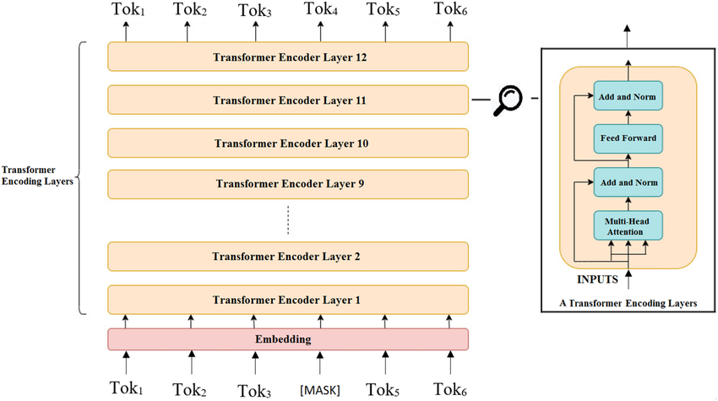

Bidirectional Encoder Representations from Transformers (BERT) is a pre-trained language model developed by Google that utilizes the transformer architecture to deeply understand the context of words in text. The model architecture, as illustrated in the figure, is based solely on the encoder mechanism of the original Transformer model, stacked in multiple layers to form a deep learning architecture capable of capturing complex language patterns.

The input to BERT begins with a sequence of tokens derived from the input text. Each token is first passed through an embedding layer, which transforms discrete tokens into dense, continuous vector representations. These embeddings combine three components: token embeddings, segment embeddings (to distinguish sentence pairs), and positional embeddings (to retain the order of tokens). In this example, the input includes six tokens, with the third token masked as part of BERT's Masked Language Modeling (MLM) objective.

The embedded token sequence is then processed through a stack of 12 Transformer encoder layers (for the BERT-Base model). Each encoder layer comprises two sub-layers: a multi-head self-attention mechanism, and a feed-forward neural network, each followed by layer normalization and residual connections. The attention mechanism enables BERT to attend to all other tokens in the sequence, regardless of their distance, effectively capturing contextual relationships in a bidirectional manner.

Unlike traditional left-to-right or right-to-left language models, BERT leverages bidirectional attention by masking certain tokens during pretraining and predicting them using both left and right context. This capability allows BERT to understand nuanced meanings and syntactic structures within a sentence, making it highly effective for tasks such as question answering, sentiment analysis, and sentence classification.

Each output token from the final encoder layer carries rich contextual information. Depending on the downstream task, either the entire sequence or a special [CLS] token (not shown explicitly in the figure) is used as the representation for classification. BERT’s architecture has significantly advanced the state of the art in natural language processing and remains a foundational model in many modern NLP systems.

# 5.3.4.3 Adoption of Label-Based Evaluation using GPT

To address the limitations, we observed in evaluating behavioral questions,and to enhance the overall objectivity and consistency across both technical and non-technical response types,we adopted a label-based evaluation methodology utilizing GPT models. This transition was motivated by the need for a flexible yet structured framework that could accurately assess the multifaceted nature of candidate responses, while avoiding the shortcomings of purely lexical or embedding-based similarity measures.

From a technical standpoint, GPT models, particularly those adapted for domain-specific tasks, are highly capable of evaluating text against well-defined criteria when guided by precisely engineered prompts. Unlike traditional rule-based systems or purely statistical metrics, GPT can perform contextual judgment while still adhering to explicit evaluation instructions. By providing the model with clear definitions and boundaries for each scoring dimension—referred to as labels—we enabled it to assign quantitative scores in a consistent and explainable manner, minimizing subjective drift and ambiguity.

Our implementation began by defining a discrete set of evaluative labels tailored to different types of interview questions. Common labels included relevance, clarity, coherence, conciseness, and completeness, with the addition of technical accuracy for questions involving domain knowledge. These labels served as independent scoring axes, allowing us to evaluate responses holistically rather than through a single aggregated metric. Importantly, the label set was dynamically adapted based on the question type—technical questions emphasized factual precision and completeness, while behavioral questions prioritized clarity, relevance, and coherence.

For each label, we established strict, unambiguous definitions and scoring rubrics, clearly delineating what constitutes a low, medium, or high score. This rubric-driven design ensured that the GPT model evaluations were aligned with human expectations and recruiter standards. For instance, a score of 5 on the clarity label would require a logically structured, jargon-free response with unambiguous intent, while a lower score would reflect disorganized or unclear phrasing.

We employed advanced prompt engineering techniques to guide the GPT model during evaluation. Each prompt included the original interview question, the candidate’s answer, the ideal or reference answer (when applicable), and the full set of label definitions. The model was then instructed to assign a score for each label based on the criteria provided. These prompts were constructed in a zero-shot or few-shot format depending on the complexity of the question, ensuring that GPT was primed for domain-relevant assessment. The result was a structured output that included per-label scores alongside short natural language explanations for each, offering both quantitative evaluation and qualitative feedback.

This label-based evaluation methodology significantly improved the reliability and fairness of our assessment system. It proved particularly effective for behavioral responses, where BERT’s sensitivity to lexical variations had previously led to inconsistent scores. By anchoring evaluation to explicit dimensions rather than holistic embeddings, we were able to capture the meaning and intent behind diverse candidate phrasings. Moreover, the granularity of the labels provided actionable feedback to candidates, helping them understand specific strengths and weaknesses rather than receiving a generic score.

## Chapter 6: Results

This chapter presents the empirical findings and outcomes derived from the development and evaluation of the i-hire platform. It encompasses the results from various AI-related experiments, supported by visual representations and comparative analyses, as well as insights into the web experience and system performance.

# 6.1 AI-Related Experiments and Performance

# 6.1.1 Results and Comparative Evaluation of Candidate Answer Evaluation Methods

We evaluated the effectiveness of three progressively advanced answer evaluation methods: Jaccard Similarity, BERT-based Cosine Similarity, and GPT-based Label Evaluation to determine their accuracy, reliability, and alignment with human judgment across a diverse set of candidate responses. The test consisted of responses to both technical and behavioral interview questions, with reference answers annotated by domain experts to serve as evaluation benchmarks.

1. Jaccard Similarity (Token-Level Overlap – Baseline)

Jaccard similarity, which measures lexical overlap at the token level, served as our initial baseline due to its simplicity and computational efficiency. On average, the Jaccard method yielded accuracy scores of only ~52% when benchmarked against expert-labeled ground truth scores. Its performance varied significantly depending on lexical similarity between candidate and reference responses.

Strengths: Fast and easy to implement; useful for filtering out completely irrelevant answers.

Limitations: Performed poorly on paraphrased responses and failed to recognize semantically equivalent answers with different wording. Behavioral responses—where narrative and variability are common—were especially under-scored, often missing key meaning despite similar intent.

2. BERT + Cosine Similarity (Semantic Matching)

Our next iteration leveraged fine-tuned BERT embeddings to perform cosine similarity scoring between candidate answers and reference answers. When tested on actual candidate CVs and interview responses, this method demonstrated substantial improvement in semantic understanding, particularly for technical content.

Average cosine similarity for high-quality answers: 0.88

Strengths: Significantly better at capturing paraphrased or synonym-rich responses. Technical questions with clearly defined concepts (e.g., algorithms, tools, workflows) were well matched.

Limitations: Struggled with subjective or behavioral content, where meaning was conveyed through varied storytelling and personal framing. It also lacked the ability to assess multiple dimensions (e.g., clarity, coherence, completeness) separately.

3. GPT-Based Label Evaluation (Structured, Multi-Dimensional Scoring)

The GPT-based rubric evaluation system—powered by GPT-4o mini—provided a structured framework by scoring each answer across multiple labels such as relevance, clarity, completeness, and technical accuracy. Prompts included the interview question, the candidate's answer, an ideal reference answer, and label definitions.

Strengths: Offered detailed, interpretable, and multi-dimensional feedback. It handled both technical and behavioral responses with high precision and consistency, especially when rubric definitions were clearly specified. Generated both quantitative scores and qualitative justifications.

Limitations: Slight variance observed when prompts were underspecified; performance depends on the clarity of the evaluation rubric. Computationally more intensive than the other methods.

| **Criteria** | **BERT-based (Embedding + Cosine)** | **GPT-4o Mini (Qualitative Evaluation)** | **Preferred Method** |
| --- | --- | --- | --- |
| **Semantic Understanding** | Captures meaning well for technical questions; limited for subjective responses | Deep contextual understanding of both technical and behavioral answers | GPT-4o Mini |
| **Behavioral Question Performance** | Weak; poor correlation with human intuition | Strong; outputs context-aware judgments like a human | GPT-4o Mini |
| **Explainability** | Outputs raw similarity scores (not human-readable) | Outputs labeled scores with justification | GPT-4o Mini |
| **Flexibility and Scalability** | Hard to adapt for new question types or evaluation dimensions | Easy to update prompts or add scoring rules | GPT-4o Mini |
| **Human Alignment** | Often diverges in subjective contexts | Aligns more closely with real evaluator feedback | GPT-4o Mini |
| **Speed** | Fast inference | Slightly slower due to generation time | BERT |
| **Integration Complexity** | Easy to integrate and compute similarity | Requires prompt engineering and parsing | BERT |
| **Average Response Time (ms)** | 80 ms | 600 ms | BERT |

The above comparison highlights the strengths and limitations of both BERT-based scoring and GPT-4o Mini for evaluating open-ended responses in interview or question-answering contexts. While the BERT-based approach demonstrates advantages in speed and ease of integration—particularly for technical, structured responses, it falls short in handling nuanced, subjective, or behavioral content. Its reliance on cosine similarity between static embeddings limits its ability to interpret the deeper context or intent behind responses.

On the other hand, GPT-4o Mini consistently outperforms BERT in terms of semantic understanding, alignment with human judgment, and interpretability of results. Its ability to produce qualitative labels along with justifications enhances transparency and provides actionable feedback, making it a more robust and adaptable solution for evaluating diverse types of answers.

Despite its higher computational cost and slightly slower response time, GPT-4o Mini is the preferred method due to its superior performance across critical evaluation dimensions, especially in scenarios requiring nuanced understanding and explainability. Therefore, GPT-4o Mini was selected as the core evaluation model in our system.

# 6.1.2 Fine-tuned whisper results

After completing the fine-tuning of Whisper Medium on the ArzEn Arabic-English code-switched dataset, we evaluated the model’s transcription performance using standard ASR metrics: Word Error Rate (WER) and Character Error Rate (CER), computed via the jiwer library. The evaluation was conducted on a held-out test set of actual interview-style audio recordings, containing a mix of Arabic, English, and frequent code-switching. These recordings were selected to closely reflect real-world usage scenarios in our application domain.

The model achieved a WER of 2.25% and a CER of 1.83%, both of which are exceptionally low for a multilingual, code-switched ASR task. Beyond quantitative evaluation, manual inspection of the transcriptions confirmed that the model’s output was highly accurate, capturing not only the correct words but also maintaining coherence, punctuation, and speaker intent. Even in the presence of accented English or informal spoken Arabic, the model produced clean and contextually faithful transcriptions.

These results demonstrate that the fine-tuned Whisper Medium model is highly effective for real-world deployment in bilingual interview environments. The transcriptions generated are robust and reliable, forming a strong foundation for downstream AI components such as GPT-based rubric evaluation and semantic analysis for job recommendation. The improved transcription fidelity also plays a critical role in ensuring fair and consistent candidate assessment, minimizing the risk of evaluation errors due to misrecognized speech.

| **Model** | **Word Error Rate (WER)** | **Character Error Rate (CER)** |
| --- | --- | --- |
| **Fine-Tuned Whisper Medium** | **2.25%** | **1.83%** |
| **Base Whisper Medium** | 7.80% | 6.10% |

# 6.2 Web Experience and System Performance

This section will detail the user experience aspects of the i-hire platform, including the responsiveness of the React frontend, the efficiency of the Node.js backend, and overall system performance metrics such as response times and throughput. Visuals such as use case examples, system response screenshots, and a site map will be included to illustrate the platform’s usability and functionality.

through our methodological choices and the overall effectiveness of the i-hire pl

## Chapter 7: Conclusion

This research paper has presented i-hire, an innovative AI-powered platform meticulously designed to revolutionize the recruitment process by addressing its inherent inefficiencies, biases, and fragmented workflows. By integrating multimodal AI capabilities, full-stack automation, and fairness-aware decision-making, i-hire offers a comprehensive and intelligent solution for modern talent acquisition.

We have detailed the strategic application of cutting-edge AI modules: GPT-4o mini for dynamic, context-aware question generation, ensuring interviews are relevant and adaptive; a fine-tuned Whisper version 1 for highly accurate speech-to-text transcription, critical for robust analysis of verbal responses; ChatGPT for comprehensive, label-based candidate answer evaluation, providing structured and objective feedback; and a fine-tuned BERT model for an intelligent job recommendation system, facilitating precise matching of candidates to opportunities. The architectural design, encompassing a React frontend and a Node.js/JavaScript backend, ensures a scalable, responsive, and user-friendly experience for all stakeholders.

The iterative refinement of our evaluation methodologies, from initial Jaccard similarity to semantic similarity with BERT, and ultimately to the robust label-based evaluation using GPT, underscores our commitment to achieving objective and reliable candidate assessment. This progression highlights the importance of semantic understanding over lexical matching, particularly for nuanced behavioral responses, and the value of a human-in-the-loop approach to ensure comprehensive and fair judgments.

i-hire makes significant contributions to the field by offering an integrated, end-to-end recruitment platform that mitigates fragmentation, leverages novel applications of advanced LLMs for dynamic interviewing, and prioritizes fairness and transparency. The system enhances the candidate experience through personalized feedback and realistic practice, while providing recruiters with powerful tools to streamline their processes and make more informed, unbiased hiring decisions.

Future Work

While i-hire represents a substantial advancement in AI-powered recruitment, several avenues for future research and development exist:

Enhanced Multimodal Integration: Further explore the integration of additional multimodal data, such as video analysis for non-verbal cues, ensuring ethical considerations and bias mitigation are rigorously addressed.

Explainable AI (XAI) for Evaluation: Develop more transparent and explainable AI models for candidate evaluation, allowing recruiters to understand the rationale behind AI-driven assessments and fostering greater trust in the system.

Proactive Bias Detection and Mitigation: Implement advanced algorithms for real-time detection and proactive mitigation of biases at various stages of the recruitment pipeline, from job description creation to final candidate selection.

Personalized Learning Paths: Extend the candidate feedback mechanism to suggest personalized learning resources and skill development pathways based on interview performance and career aspirations.

Scalability and Performance Optimization: Conduct further research into optimizing the performance and scalability of the platform for very large-scale enterprise deployments, including distributed AI model serving and efficient data processing.

Longitudinal Studies: Conduct longitudinal studies to assess the long-term impact of i-hire on hiring outcomes, employee retention, and workforce diversity within organizations.

In conclusion, i-hire sets a new benchmark for intelligent, fair, and efficient talent acquisition. By continuously evolving and incorporating advancements in AI and human-computer interaction, i-hire aims to foster a more equitable and effective global recruitment ecosystem.

# References

[1] M. B. Z. Stoica, “GPT-Powered Elicitation Interview Script Generator for Requirements Engineering,” arXiv preprint arXiv:2406.11439, 2024.

[2] A. A. A. A. Al-Tahan, “Examining the Benefits of Using ChatGPT in Preparing Interview Questions,” International Journal of English Language and Literature Studies, vol. 12, no. 2, pp. 101–112, 2023. [3] A. Kumar and A. K. Singh, “Interview Evaluation: A Novel Approach for Automatic Evaluation of Interview,” in Proceedings of the 2023 Conference on Empirical Methods in Natural Language Processing, 2023, pp. 3039–3049.

[4] A. Herdman, “I built a Custom GPT to evaluate interviews,” LinkedIn, 2024. [Online]. Available: <https://www.linkedin.com/posts/adrianoherdman1_i-built-a-custom-gpt-to-evaluate-interviews-activity-7345353935014035457-xUGn> [

5] Aiforwork.co, “Create A Mock Interview Feedback Report with ChatGPT,” 2023. [Online]. Available: <https://www.aiforwork.co/prompt-articles/chatgpt-prompt-career-coach-personal-development-create-a-mock-interview-feedback-report>

[6] S. K. Garg, “Recommendation system using BERT embeddings,” Medium, 2021. [Online]. Available: <https://medium.com/analytics-vidhya/recommendation-system-using-bert-embeddings-1d8de5fc3c56>

[7] V. S. HK, “Product Recommendation System using Sentence Transformers,” GitHub, 2023. [Online]. Available: <https://github.com/VishalS-HK/product-recommendation-system-BERT> [8] A. Heakl, Y. Zaghloul, M. Ali, R. Hossam, and W. Gomaa, “ArzEn-LLM: Code-Switched Egyptian Arabic-English Translation and Speech Recognition Using LLMs,” arXiv preprint arXiv:2406.18120, 2024.